Section 6: Lower Extremity

Card ID: 6.1
Image file: L1344_760185
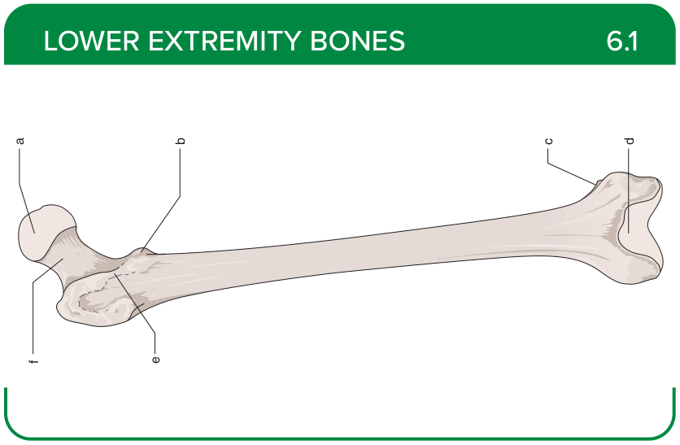
Title: Femur (Anterior)
Activity Interaction: Drag and drop
Back-of-Card Content:
a. Head
b. Lesser trochanter
c. Adductor tubercle
d. Patellar surface
e. Intertrochanteric line
f. Neck

Card ID: 6.2
Image file: L1344_760186
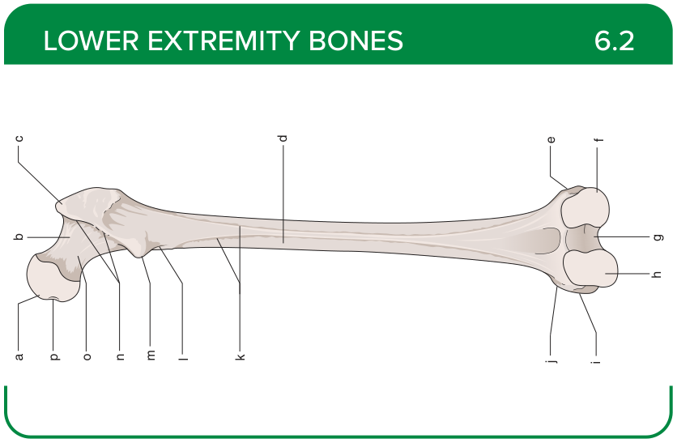
Title: Femur (Posterior)
Activity Interaction: Drag and drop
Back-of-Card Content:
a. Head
b. Trochanteric fossa
c. Greater trochanter
d. Shaft
e. Lateral epicondyle
f. Lateral condyle
g. Intercondylar fossa
h. Medial condyle
i. Medial epicondyle
j. Adductor tubercle
k. Linea aspera
l. Pectineal line
m. Lesser trochanter
n. Intertrochanteric crest
o. Neck
p. Fovea for ligament of the head

Card ID: 6.3
Image file: L1344_760187
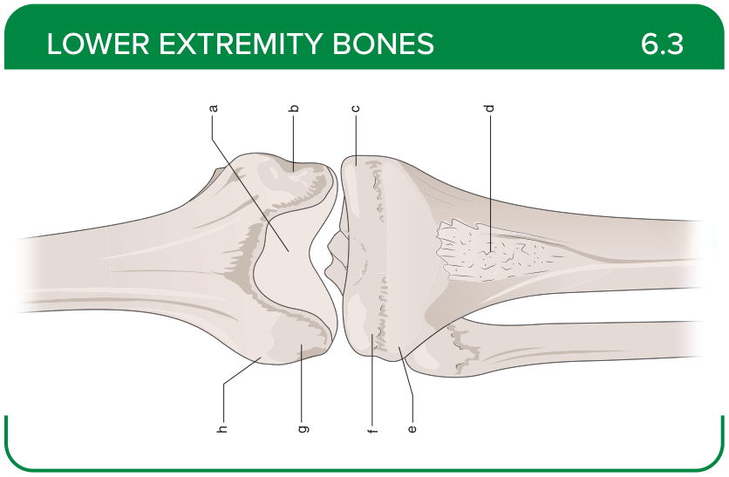
Title: Tibiofemoral Joint (Anterior)
Activity Interaction: Drag and drop
Back-of-Card Content:
a. Intercondylar notch
b. Medial epicondyle
c. Medial condyle
d. Tibial tuberosity
e. Tibial condyle
f. Lateral condyle
g. Femoral condyle
h. Lateral epicondyle

Card ID: 6.4
Image file: L1344_760188
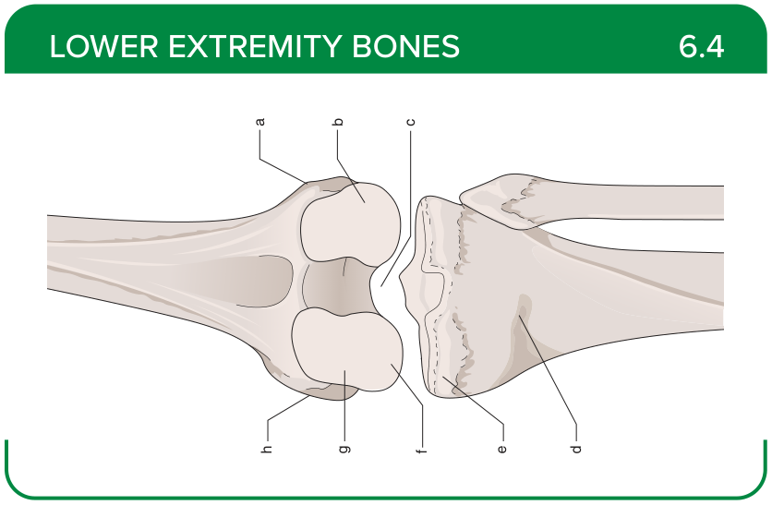
Title: Tibiofemoral Joint (Posterior)
Activity Interaction: Drag and drop
Back-of-Card Content:
a. Lateral epicondyle
b. Lateral condyle
c. Intercondylar notch
d. Tibial tuberosity
e. Tibial condyle
f. Medial condyle
g. Femoral condyle
h. Medial epicondyle

Card ID: 6.5
Image file: L1344_760189
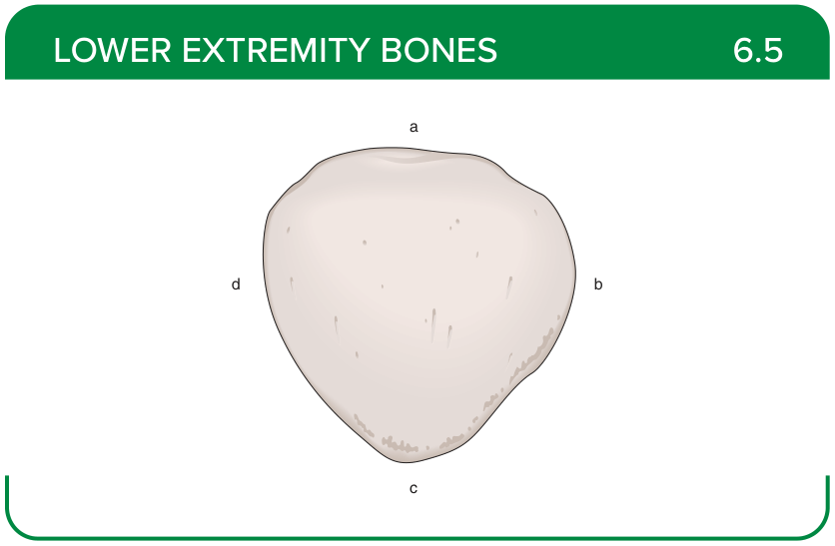
Title: Patella (Anterior)
Activity Interaction: Drag and drop
Back-of-Card Content:
a. Base
b. Lateral border
c. Apex
d. Medial border

Card ID: 6.6
Image file: L1344_760190
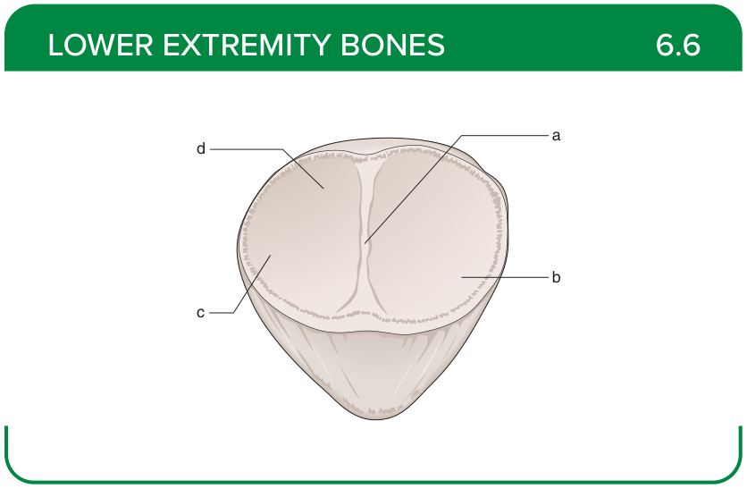
Title: Patella (Posterior)
Activity Interaction: Drag and drop
Back-of-Card Content:
a. Vertical ridge
b. Lateral facet
c. Odd facet
d. Medial facet

Card ID: 6.7
Image file: L1344_760191
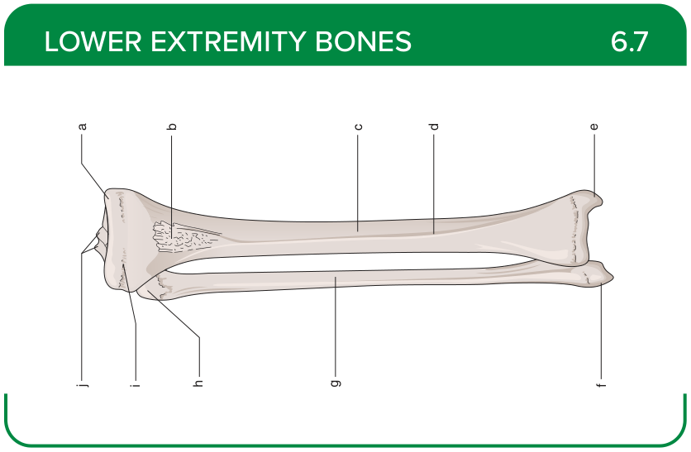
Title: Tibiofibular Joint (Anterior)
Activity Interaction: Drag and drop
Back-of-Card Content:
a. Medial condyle
b. Tibial tuberosity
c. Tibia
d. Anterior crest
e. Medial malleolus
f. Lateral malleolus
g. Fibula
h. Head
i. Lateral condyle
j. Tibial spines

Card ID: 6.8
Image file: L1344_760192
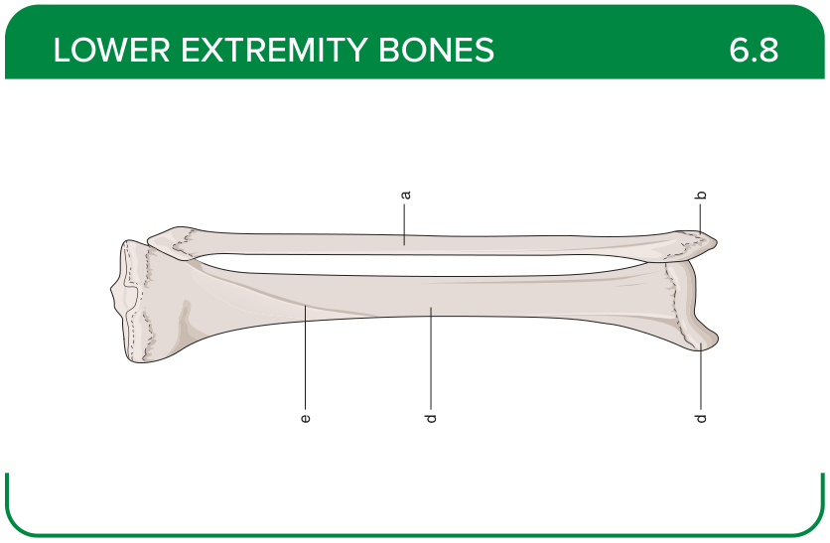
Title: Tibiofibular Joint (Posterior)
Activity Interaction: Drag and drop
Back-of-Card Content:
a. Fibula
b. Lateral malleolus
c. Medial malleolus
d. Tibia
e. Soleal line

Card ID: 6.9
Image file: L1344_760193
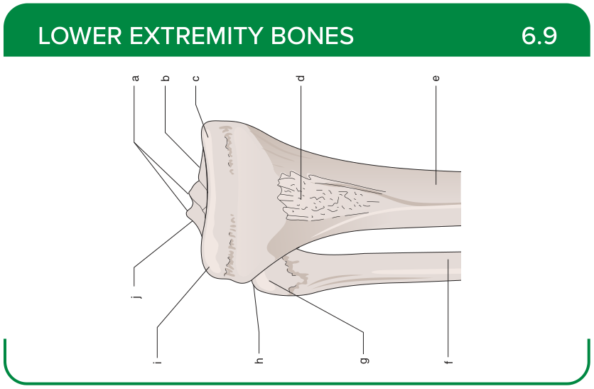
Title: Proximal Tibiofibular Joint (Anterior)
Activity Interaction: Drag and drop
Back-of-Card Content:
a. Tibial spines
b. Medial intercondylar tubercle
c. Medial condyle
d. Tibial tuberosity
e. Tibia
f. Fibula
g. Head of the fibula
h. Apex or styloid process of the fibula
i. Lateral condyle
j. Intercondylar eminence

Card ID: 6.10
Image file: L1344_760194
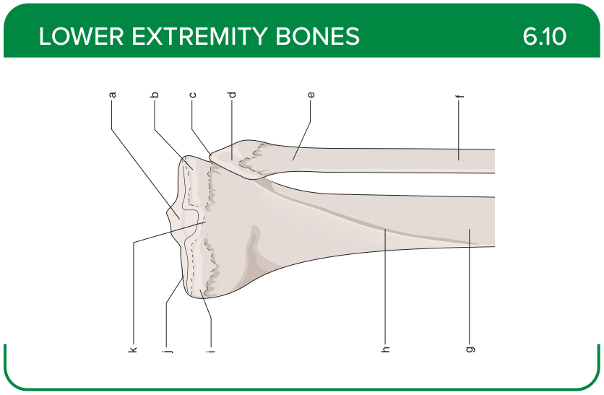
Title: Proximal Tibiofibular Joint (Posterior)
Activity Interaction: Drag and drop
Back-of-Card Content:
a. Superior articular surface
b. Lateral condyle
c. Apex
d. Head of the fibula
e. Neck
f. Fibula
g. Tibia
h. Soleal line
i. Medial condyle
j. Medial plateau
k. Posterior intercondylar area

Card ID: 6.11
Image file: L1344_760195
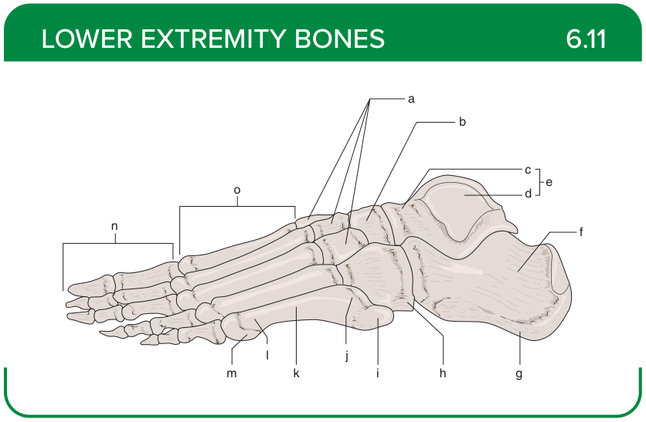
Title: Foot (Lateral)
Activity Interaction: Drag and drop
Back-of-Card Content:
a. Cuneiforms
b. Navicular
c. Head and neck
d. Body
e. Talus
f. Calcaneus
g. Tubercle
h. Cuboid
i. Tuberosity
j. Base
k. Shaft
l. Head
m. Tubercle
n. Phalanges
o. Metatarsals

Card ID: 6.12
Image file: L1344_760196
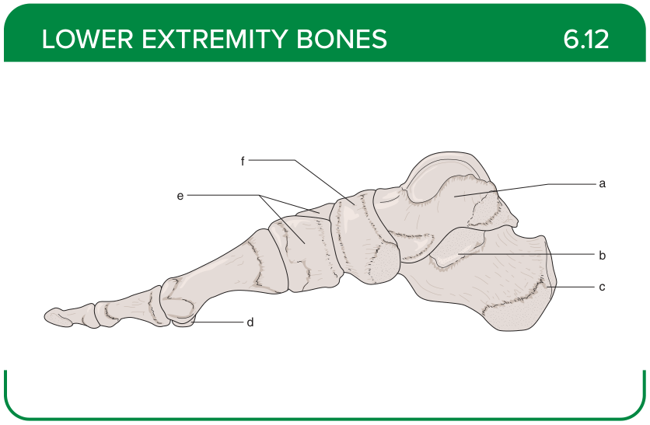
Title: Foot (Medial)
Activity Interaction: Drag and drop
Back-of-Card Content:
a. Talus
b. Sustentaculum tali
c. Calcaneus
d. Sesamoid
e. Cuneiforms
f. Navicular

Card ID: 6.13
Image file: L1344_760197
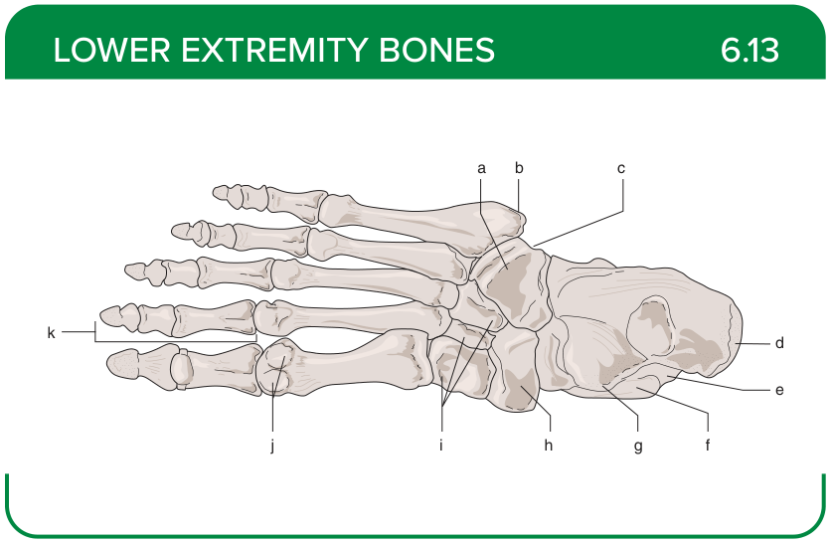
Title: Foot (Plantar)
Activity Interaction: Drag and drop
Back-of-Card Content:
a. Cuboid
g. Talus
b. Tuberosity
h. Navicular
c. Groove for peroneus longus
i. Cuneiforms
d. Tuberosity
j. Sesamoids
e. Calcaneus
k. Phalanges
f. Sustentaculum tali

Card ID: 6.14
Image file: L1344_760198
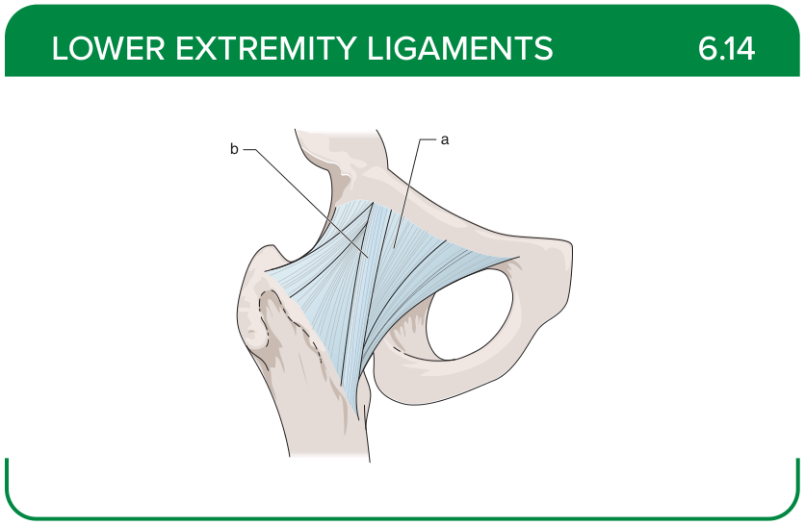
Title: Hip Ligaments (Anterior)
Activity Interaction: fill-in-the-blank
Back-of-Card Content:
a. Pubofemoral ligament: restricts hip abduction and extension
b. Iliofemoral ligament: restricts excessive hip joint extension

Card ID: 6.15
Image file: L1344_760199
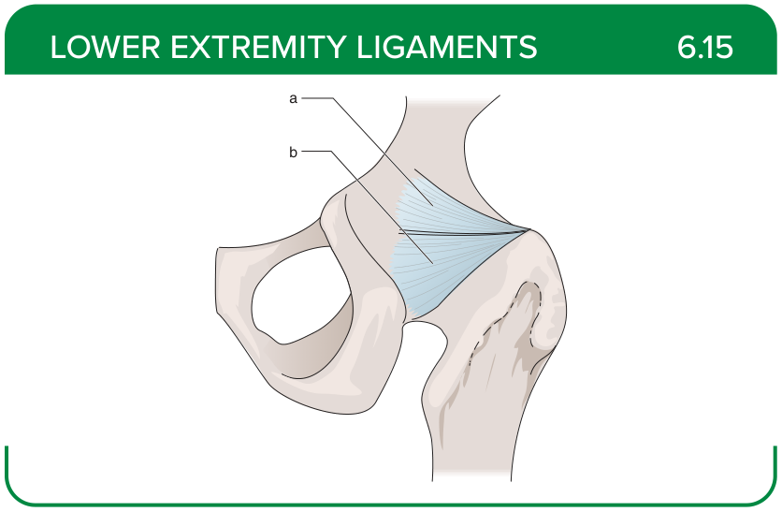
Title: Hip Ligaments (Posterior)
Activity Interaction: fill-in-the-blank
Back-of-Card Content:
a. Iliofemoral ligament: restricts excessive hip joint extension
b. Ischiofemoral ligament: reinforces posterior capsule, limits internal rotation and adduction

Card ID: 6.16
Image file: L1344_760200
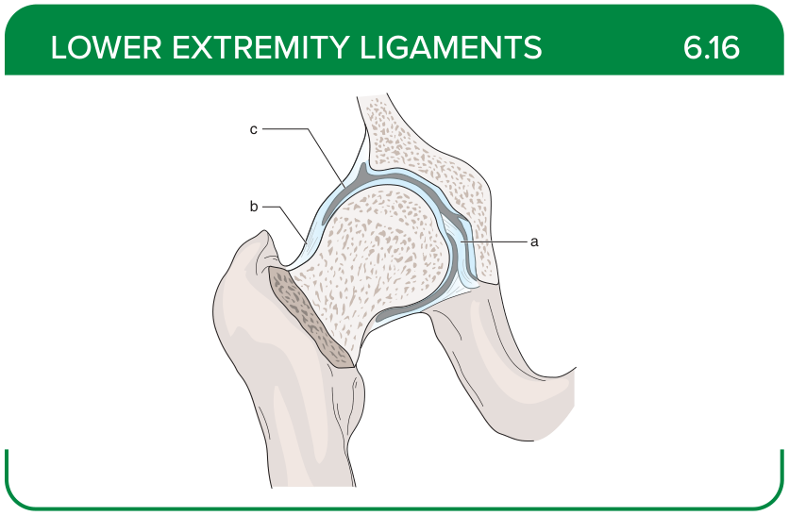
Title: Hip Ligaments (Intracapsular)
Activity Interaction: fill-in-the-blank
Back-of-Card Content:
a. Ligamentum teres: restricts excessive movement of the femoral head within the acetabulum
b. Annular ligament: ensures joint stability during weight bearing and secures the femoral head into the acetabulum
c. Joint capsule: stabilize the femoral head in the acetabulum

Card ID: 6.17
Image file: L1344_760201
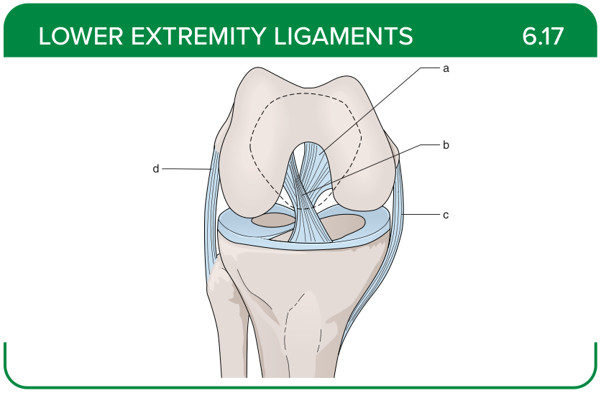
Title: Knee Intracapsular Ligaments
Activity Interaction: fill-in-the-blank
Back-of-Card Content:
a. Posterior cruciate ligament: restricts posterior tibial translation and excessive rotation at high flexion angles
b. Anterior cruciate ligament: restricts anterior tibial translation, internal rotation, and hyperextension
c. Medial collateral ligament: restricts valgus stress and external tibial rotation
d. Lateral collateral ligament: restricts varus stress and external tibial rotation

Card ID: 6.18
Image file: L1344_760202
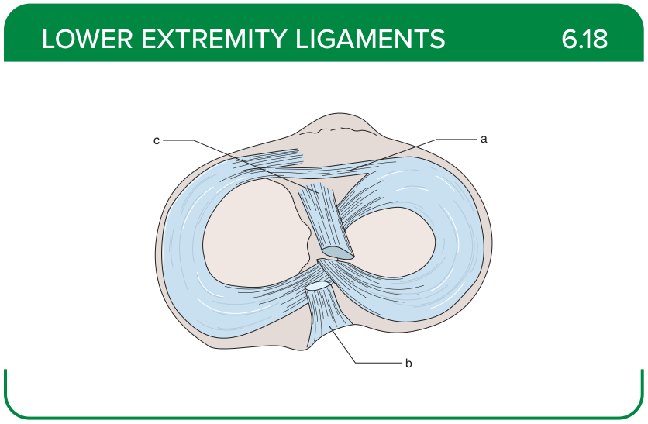
Title: Knee Intracapsular Ligaments (Superior)
Activity Interaction: fill-in-the-blank
Back-of-Card Content:
a. Transverse ligament: provides stability by minimizing meniscal movement
b. Posterior cruciate ligament: restricts posterior tibial translation and excessive rotation at high flexion angles
c. Anterior cruciate ligament: restricts anterior tibial translation, internal rotation, and hyperextension

Card ID: 6.19
Image file: L1344_760203
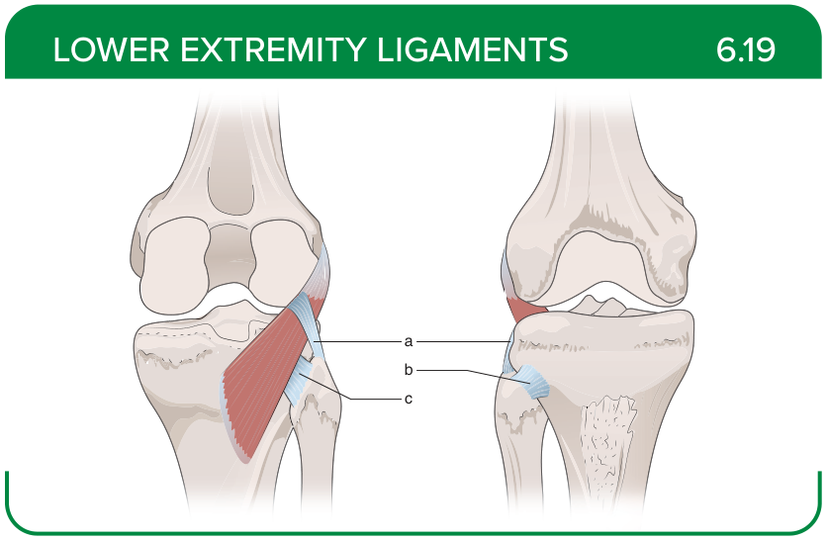
Title: Tibiofibular Joint (Posterior)
Activity Interaction: fill-in-the-blank
Back-of-Card Content:
a. Popliteofibular ligament: restricts external tibial rotation, posterolateral translation, and varus rotation
b. Anterior proximal tibiofibular ligament: restricts posterior and medial translation of the fibular head, and fibular rotation
c. Posterior proximal tibiofibular ligament: restricts anterior and lateral translation of the fibular head, and fibular rotation

Card ID: 6.20
Image file: L1344_760204
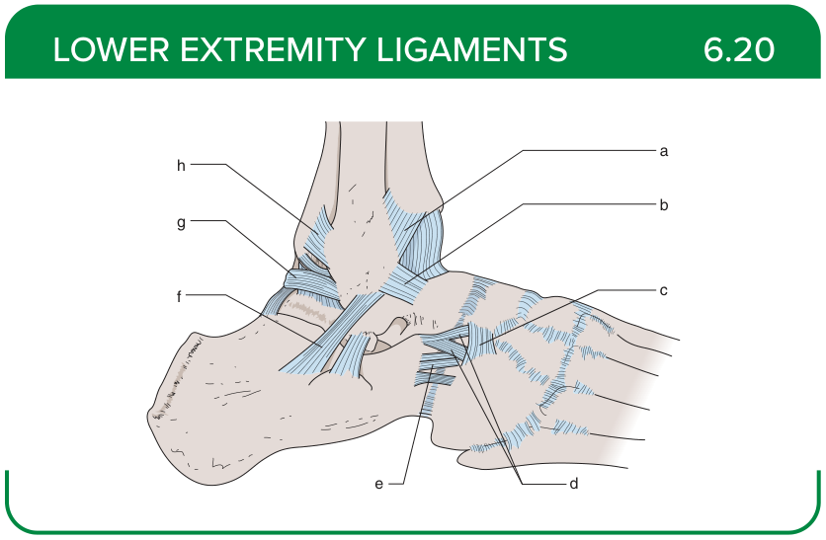
Title: Foot Ligaments (Lateral)
Activity Interaction: fill-in-the-blank
Back-of-Card Content:
a. Anterior tibiofibular ligament (AITFL): maintains stability between the tibia and fibula
b. Anterior talofibular (ATFL) ligament: restricts inversion and plantar flexion
c. Cuboideonavicular ligament: restricts excessive movement between the cuboid and the navicular
d. Bifurcate (Chopart) ligament: restricts excessive midfoot mobility
e. Calcaneocuboid ligament: restricts excessive movement between the calcaneus and cuboid
f. Calcaneofibular ligament: restricts inversion during dorsiflexion
g. Posterior talofibular ligament: restricts extreme inversion and dorsiflexion
h. Posterior tibiofibular ligament: restricts excessive separation between the tibia and fibula

Card ID: 6.21
Image file: L1344_760205
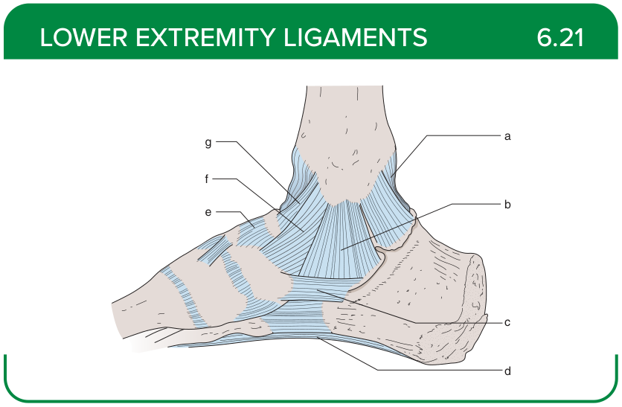
Title: Foot Ligaments (Medial)
Activity Interaction: fill-in-the-blank
Back-of-Card Content:
a. Posterior talotibial ligament: resists excessive inversion
b. Calcaneotibial ligament: resists excessive inversion
c. Calcaneonavicular (spring) ligament: restricts depression of the medial arch
d. Long plantar ligament: restricts flattening of the longitudinal arch
e. Dorsal talonavicular ligament: restricts midtarsal joint instability
f. Tibionavicular ligament: restricts subluxation of the ankle joint and stabilizes the ankle during eversion
g. Anterior talotibial ligament: restricts eversion of the foot

Card ID: 6.22
Image file: L1344_760206
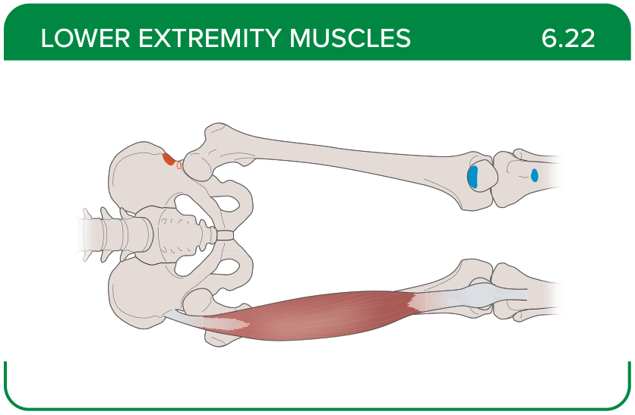
Title: Rectus femoris
Activity Interaction: select all that apply
Back-of-Card Content:
Proximal insertion:
- *anterior inferior iliac spine
- *area superior to the acetabulum
- greater trochanter of the femur
- lateral condyle of the femur
Distal insertion:
- *patella via the quadriceps tendon
- *tibial tuberosity via the patellar ligament
- linea aspera
- medial tibial condyle on the pes anserinus
Innervation:
- *femoral nerve
- tibial nerve
- superior gluteal nerve (L4-S1)
- obturator nerve
Action:
- *hip flexion
- *knee extension
- knee flexion
- hip external rotation

Card ID: 6.23
Image file: L1344_760207
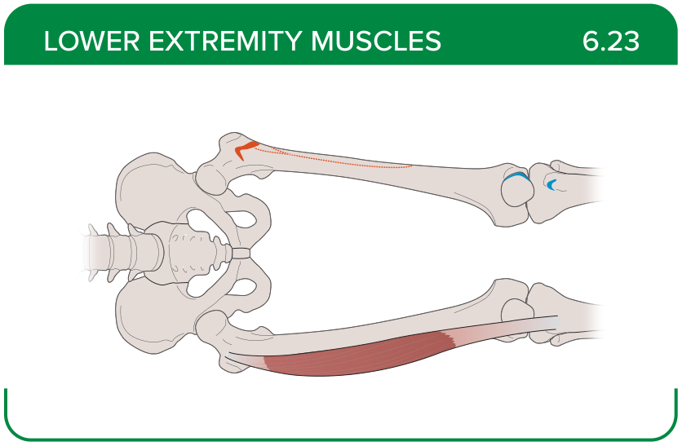
Title: Vastus lateralis
Activity Interaction: select all that apply
Back-of-Card Content:
Proximal insertion:
- *greater trochanter
- *intertrochanteric line, proximal to the lateral lip of the linea aspera
- pubic rami
- ischial tuberosity
Distal insertion:
- *patella via the quadriceps tendon
- *tibial tuberosity via the patellar ligament
- linea aspera
- medial tibial condyle on the pes anserinus
Innervation:
- *femoral nerve
- tibial nerve
- superior gluteal nerve (L4-S1)
- obturator nerve
Action:
- hip flexion
- *knee extension
- knee flexion
- hip external rotation

Card ID: 6.24
Image file: L1344_760208
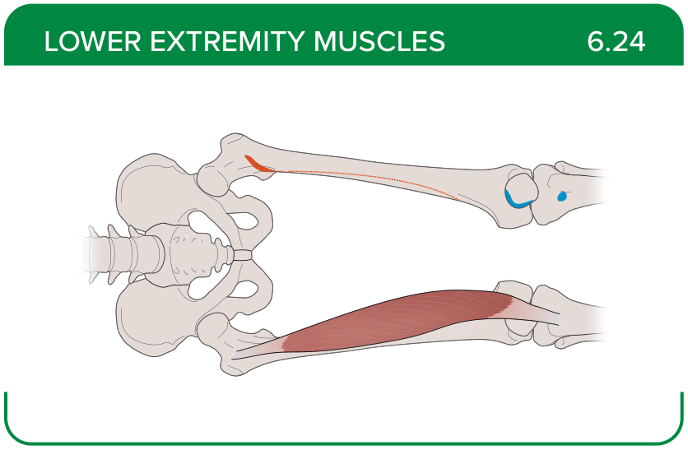
Title: Vastus medialis
Activity Interaction: select all that apply
Back-of-Card Content:
Proximal insertion:
- *intertrochanteric line and linea aspera
- greater trochanter of the femur
- iliopectineal line
- lesser trochanter of the femur
Distal insertion:
- *patella via the quadriceps tendon
- *tibial tuberosity via the patellar ligament
- linea aspera
- medial tibial condyle on the pes anserinus
Innervation:
- *femoral nerve
- tibial nerve
- superior gluteal nerve (L4-S1)
- obturator nerve
Action:
- hip flexion
- *knee extension
- knee flexion
- hip external rotation

Card ID: 6.25
Image file: L1344_760209
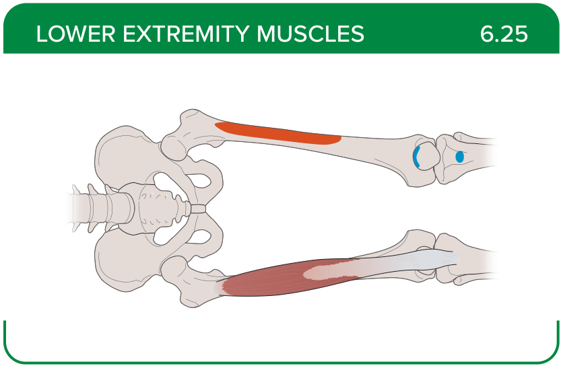
Title: Vastus intermedius
Activity Interaction: select all that apply
Back-of-Card Content:
Proximal insertion:
- *proximal two thirds of the anterior femur
- greater trochanter of the femur
- superior aspect of the pubic bone
- lesser trochanter of the femur

Proximal insertion:
- *patella via the quadriceps tendon
- *tibial tuberosity via the patellar ligament
- linea aspera
- medial tibial condyle on the pes anserinus
Innervation:
- *femoral nerve
- tibial nerve
- superior gluteal nerve (L4-S1)
- obturator nerve
Action:
- hip flexion
- *knee extension
- knee flexion
- hip external rotation

Card ID: 6.26
Image file: L1344_760210
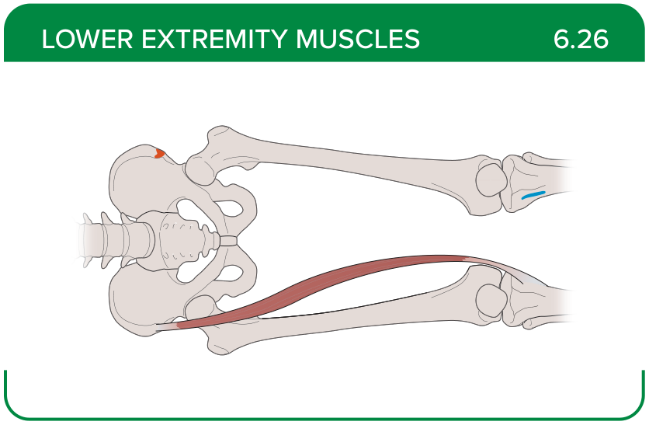
Title: Sartorius
Activity Interaction: select all that apply
Back-of-Card Content:
Proximal insertion:
- *anterior superior iliac spine
- pubic rami
- lateral condyle of the femur
- greater trochanter of the femur
Distal insertion:
- *inferior to the medial condyle of the tibia on the pes anserinus
- lateral meniscus
- linea aspera
- pectineal line of the femur

Innervation:
- *femoral nerve
- tibial nerve
- superior gluteal nerve (L4-S1)
- obturator nerve
Action:
- *hip flexion, abduction, and external rotation
- knee flexion and lower leg internal rotation
- *hip flexion, adduction, and internal rotation
- *hip flexion, abduction, and internal rotation

Card ID: 6.27
Image file: L1344_760211
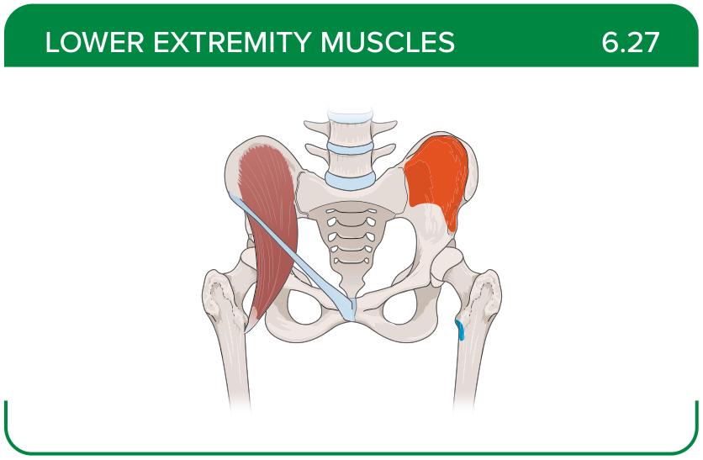
Title: Iliacus
Activity Interaction: select all that apply
Back-of-Card Content:
Proximal insertion:
- *iliac fossa
- *iliac crest
- *lateral sacrum
- lumbar vertebrae L1-L5
Distal insertion:
- *lesser trochanter of the femur
- pubic rami
- ischial tuberosity
- greater trochanter of the femur

Innervation:
- *femoral nerve
- tibial nerve
- superior gluteal nerve (L4-S1)
- obturator nerve

Action:
- *trunk and thigh flexion
- hip external rotation
- stabilization of the hip joint
- assistance in abduction of the thigh

Card ID: 6.28
Image file: L1344_760212
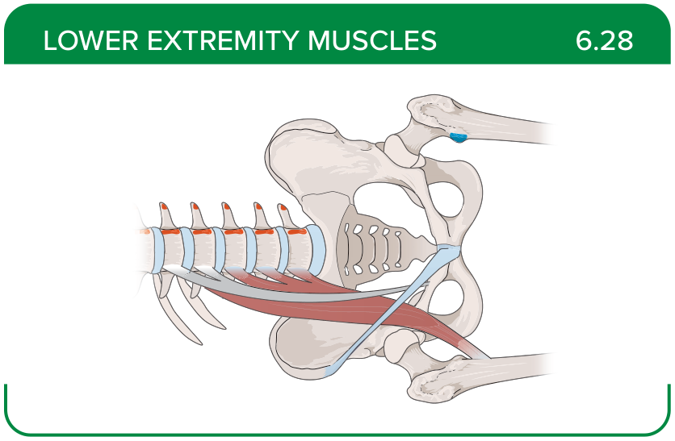
Title: Psoas major
Activity Interaction: select all that apply
Back-of-Card Content:
Proximal insertion:
- iliac fossa
- iliac crest
- lateral sacrum
- *lumbar vertebrae L1-L5
Distal insertion:
- *lesser trochanter of the femur
- pubic rami
- ischial tuberosity
- greater trochanter of the femur
Innervation:
- femoral nerve
- *anterior rami of the lumbar spinal nerves
- superior gluteal nerve (L4-S1)
- obturator nerve
Action:
- * thigh flexion
- hip external rotation
- *vertebral column lateral flexion
- assistance in abduction of the thigh

Card ID: 6.29
Image file: L1344_760213
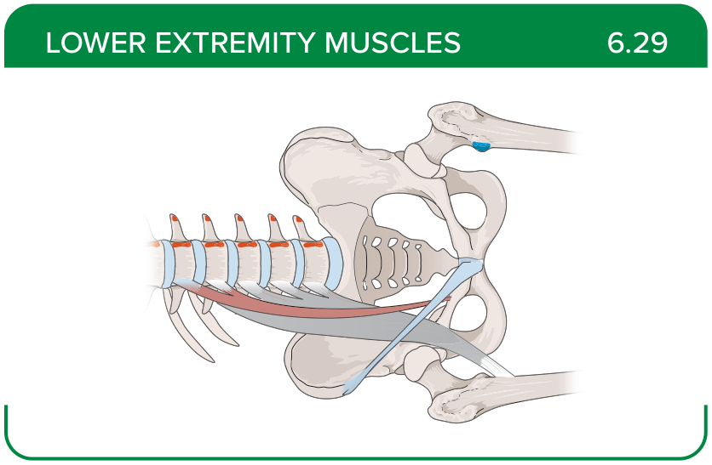
Title: Psoas minor
Activity Interaction: select all that apply
Back-of-Card Content:
Proximal insertion:
- *T12 and L1 intervertebral discs and bodies
- iliac fossa
- iliac crest
- lateral sacrum
Distal insertion:
- *iliopectineal line
- lesser trochanter of the femur
- pubic rami
- ischial tuberosity
Innervation:
- *anterior ramus of L1 spinal nerve
- obturator nerve
- femoral nerve
- superior gluteal nerve (L4-S1)
Action:
- *pelvis flexion
- hip external rotation
- vertebral column lateral flexion
- assistance in abduction of the thigh

Card ID: 6.30
Image file: L1344_760214
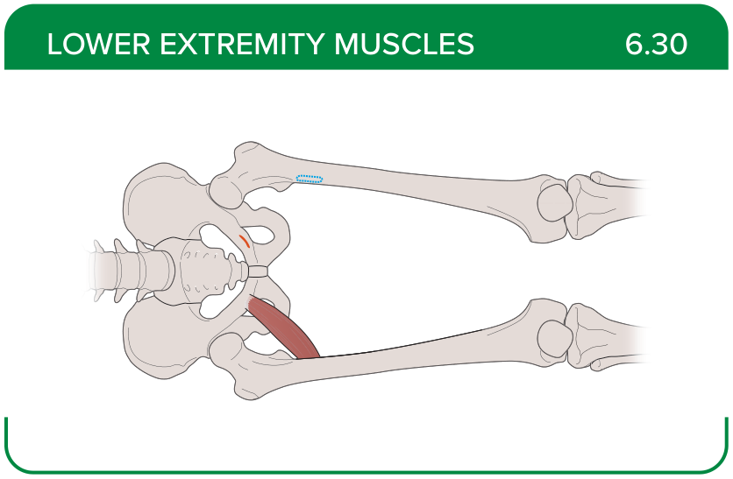
Title: Pectineus
Activity Interaction: select all that apply
Back-of-Card Content:
Proximal insertion:
- iliopectineal line
- *superior aspect of the pubic bone
- ischial tuberosity
- ischial rami
Distal insertion:
- *pectineal line of the femur
- lesser trochanter of the femur
- pubic rami
- ischial tuberosity
Innervation:
- anterior ramus of L1 spinal nerve
- obturator nerve
- *femoral nerve
- superior gluteal nerve (L4-S1)

Action:
- *hip flexion
- *hip adduction
- *hip external rotation
- hip internal rotation

Card ID: 6.31
Image file: L1344_760215
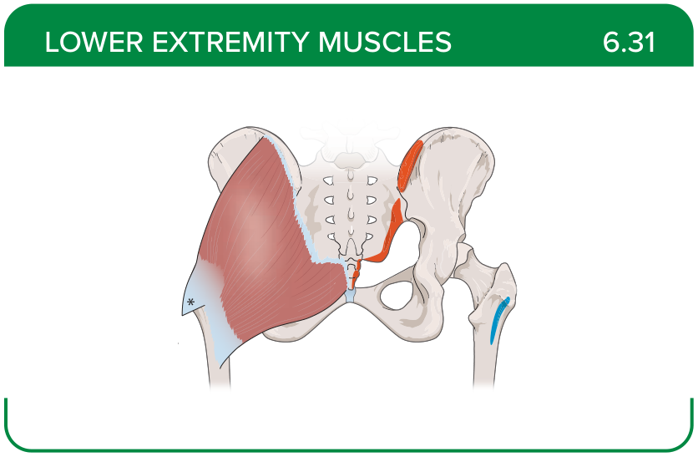
Title: Gluteus maximus
Activity Interaction: select all that apply
Back-of-Card Content:
Proximal insertion:
- *lateroposterior surface of the sacrum and coccyx
- *gluteal surface of the ilium
- *thoracolumbar fascia
- *sacrotuberous ligament
Distal insertion:
- *iliotibial tract
- *gluteal tuberosity of the femur
- lesser trochanter of the femur
- linea aspera
Innervation:
- *inferior gluteal nerve (L5-S2)
- superior gluteal nerve (L4-S1)
- tibial nerve
- femoral nerve
Action:
- *hip extension
- hip internal rotation
- assistance in adduction of the thigh

Card ID: 6.32
Image file: L1344_760216
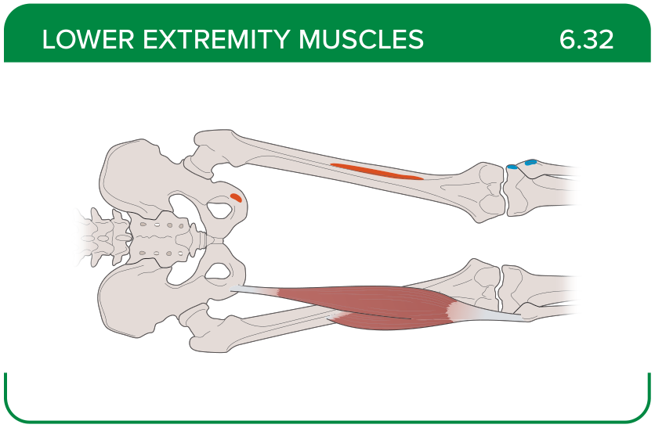
Title: Biceps femoris
Activity Interaction: select all that apply
Back-of-Card Content:
Proximal insertion:
- *ischial tuberosity
- *linea aspera
- pubic rami
Distal insertion:
- *head of the fibula
- proximal tibia
- distal to the medial tibial condyle on the pes anserinus
Innervation:
- *tibial nerve
- *fibular nerve
- femoral nerve
- deep fibular (peroneal) nerve
Action:
- hip extension and external rotation
- *knee flexion
- lower leg external rotation
- hip extension and internal rotation

Card ID: 6.33
Image file: L1344_760217
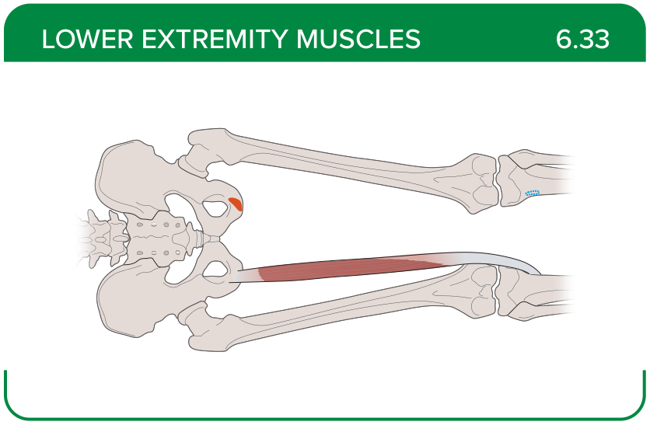
Title: Semitendinosus
Activity Interaction: select all that apply
Back-of-Card Content:
Proximal insertion:
- *ischial tuberosity
- ischial rami
- superior aspect of the pubic bone
- iliopectineal line
Distal insertion:
- *inferior to the medial tibial condyle on the pes anserinus
- lateral meniscus
- anteromedial fibula shaft
- pectineal line of the femur
Innervation:
- *tibial nerve
- fibular nerve
- femoral nerve
- deep fibular (peroneal) nerve
Action:
- *hip extension
- *knee flexion
- *lower leg internal rotation
- hip adduction

Card ID: 6.34
Image file: L1344_760218
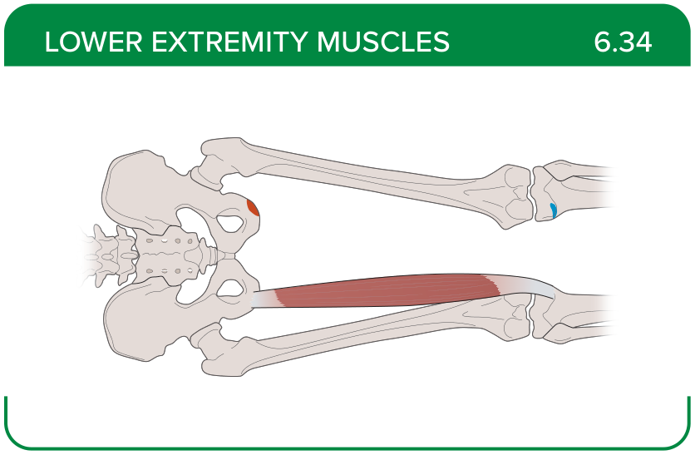
Title: Semimembranosus
Activity Interaction: select all that apply
Back-of-Card Content:
Proximal insertion:
- *ischial tuberosity
- ischial rami
- superior aspect of the pubic bone
- iliopectineal line
Distal insertion:
- inferior to the medial tibial condyle on the pes anserinus
- *medial tibial condyle
- anteromedial fibula shaft
- pectineal line of the femur
Innervation:
- *tibial nerve
- fibular nerve
- femoral nerve
- deep fibular (peroneal) nerve
Action:
- *hip extension
- *knee flexion
- *lower leg internal rotation
- hip adduction

Card ID: 6.35
Image file: L1344_760219
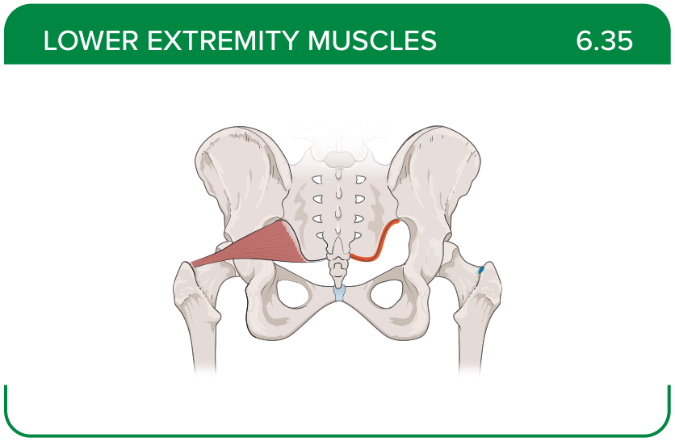
Title: Piriformis
Activity Interaction: select all that apply
Back-of-Card Content:
Proximal insertion:
- *anterolateral surface of the sacrum
- superior aspect of the pubic bone
- ischial tuberosity
Distal insertion:
- *greater trochanter of the femur
- lesser trochanter of the femur
- lateral condyle of the femur
Innervation:
- tibial nerve
- fibular nerve
- deep fibular (peroneal) nerve
- *spinal nerves L5-S2
Action:
- *hip external rotation
- *hip abduction
- hip internal rotation
- hip extension

Card ID: 6.36
Image file: L1344_760220
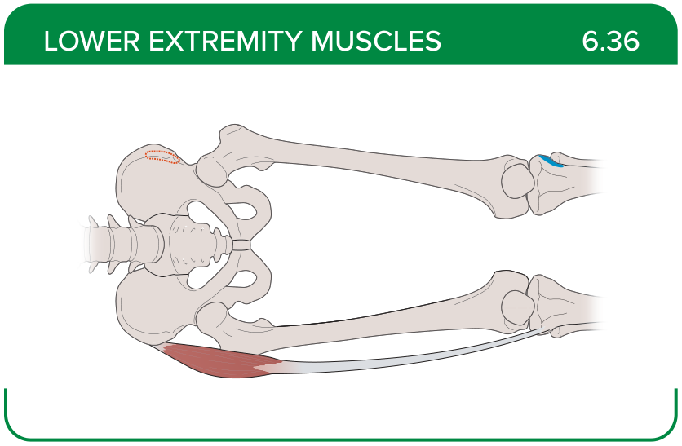
Title: Tensor fascia latae
Activity Interaction: select all that apply
Back-of-Card Content:
Proximal insertion:
- *anterior aspect of the iliac crest
- anterior superior iliac spine (ASIS)
- greater trochanter of the femur
- lesser trochanter of the femur
Distal insertion:
- *iliotibial tract
- anteromedial fibula shaft
- distal to the medial tibial condyle on the pes anserinus
Innervation:
- *superior gluteal nerve (L4-S1)
- obturator nerve
- femoral nerve
- tibial nerve
Action:
- *thigh internal rotation
- *maintenance of stability between the leg and the trunk
- flexion of the knee when the foot is dorsiflexed

Card ID: 6.37
Image file: L1344_760221
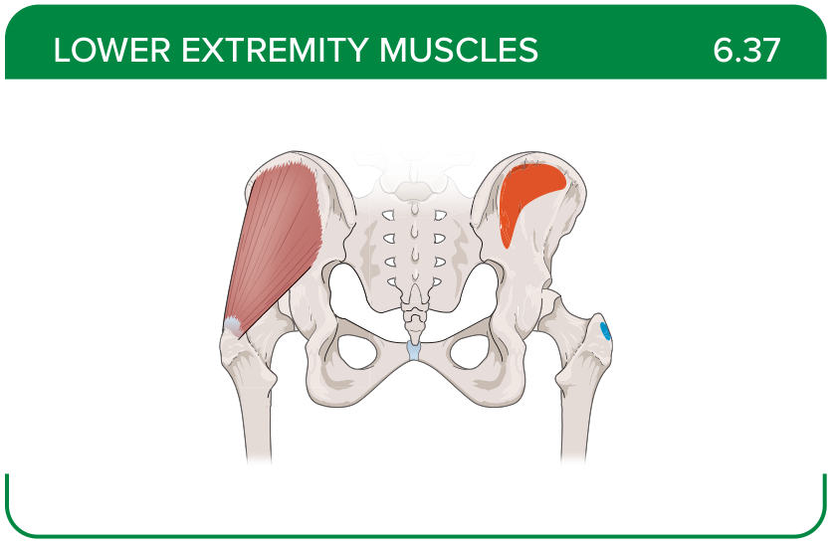
Title: Gluteus medius
Activity Interaction: select all that apply
Back-of-Card Content:
Proximal insertion:
- *lateral surface of the ilium
- external surface of the ilium
- lateroposterior surface of the sacrum and coccyx
Distal insertion:
- *greater trochanter of the femur
- lesser trochanter of the femur
- iliopectineal line
- linea aspera
Innervation:
- *superior gluteal nerve (L4-S1)
- obturator nerve
- femoral nerve
- tibial nerve
Action:
- *hip abduction
- *hip internal rotation
- hip external rotation
- hip extension

Card ID: 6.38
Image file: L1344_760222
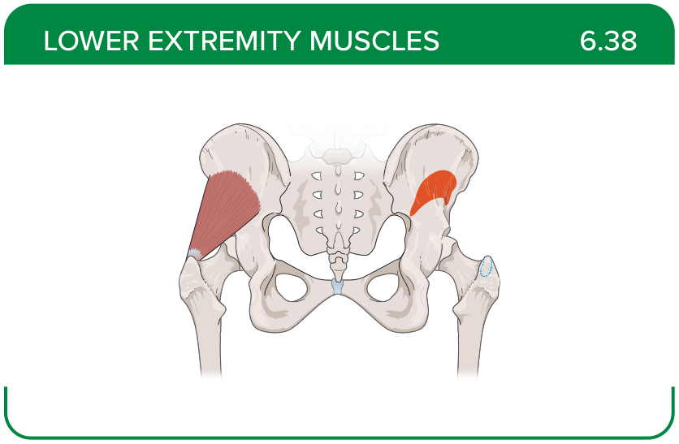
Title: Gluteus minimus
Activity Interaction: select all that apply
Back-of-Card Content:
Proximal insertion:
- lateral surface of the ilium
- *external surface of the ilium
- lateroposterior surface of the sacrum and coccyx
Distal insertion:
- *greater trochanter of the femur
- lesser trochanter of the femur
- iliopectineal line
- linea aspera
Innervation:
- *superior gluteal nerve (L4-S1)
- obturator nerve
- femoral nerve
- tibial nerve
Action:
- *hip abduction
- *hip internal rotation
- hip external rotation
- hip extension

Card ID: 6.39
Image file: L1344_760223
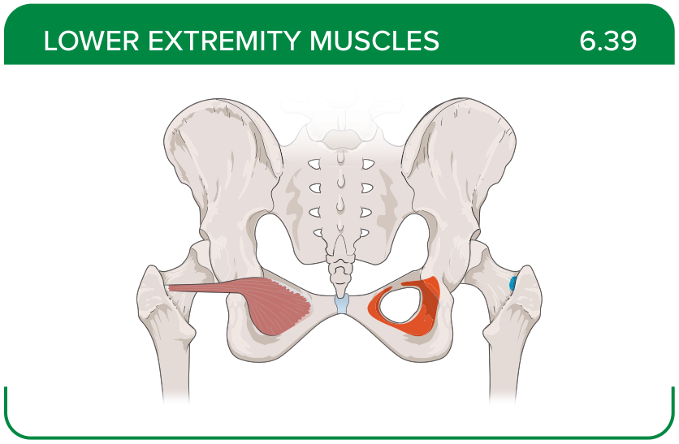
Title: Obturator internus
Activity Interaction: select all that apply
Back-of-Card Content:
Proximal insertion:
- *inner surface of the obturator membrane
- *greater sciatic notch
- *margins of the obturator foramen
- ischial spine
Distal insertion:
- *greater trochanter in front of the piriformis
- trochanteric fossa of the posterior femur
- trochanteric crest of the femur
Innervation:
- *nerve to the obturator internus
- obturator nerve
- nerve to the quadratus femoris
- tibial nerve
Action:
- *hip external rotation
- *stabilization of the hip joint
- *assistance in abduction of the thigh
- internal rotation
- assistance in adduction of the thigh

Card ID: 6.40
Image file: L1344_760224
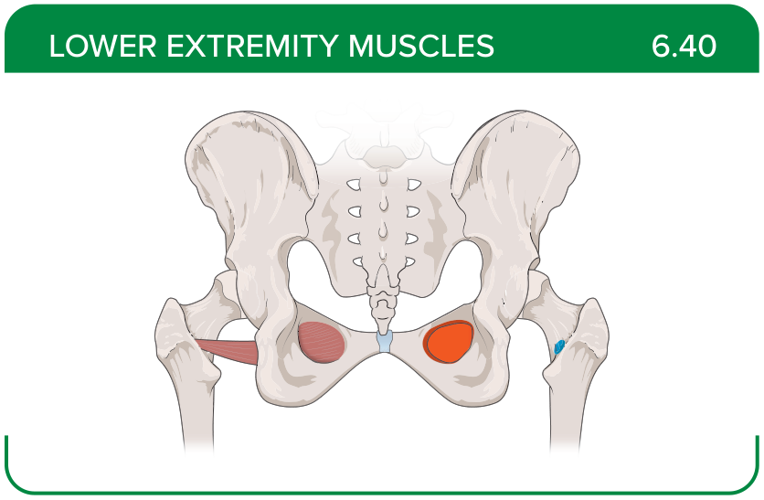
Title: Obturator externus
Activity Interaction: select all that apply
Back-of-Card Content:
Proximal insertion:
- *outer surface of the obturator membrane
- pubis
- *ischium
- *margins of the obturator foramen
Distal insertion:
- *trochanteric fossa of the posterior femur
- trochanteric crest of the femur
- greater trochanter
Innervation:
- *obturator nerve
- nerve to the obturator internus
- nerve to the quadratus femoris
- tibial nerve
Action:
- *hip external rotation
- *stabilization of the hip joint
- *assistance in abduction of the thigh
- internal rotation
- assistance in adduction of the thigh

Card ID: 6.41
Image file: L1344_760225
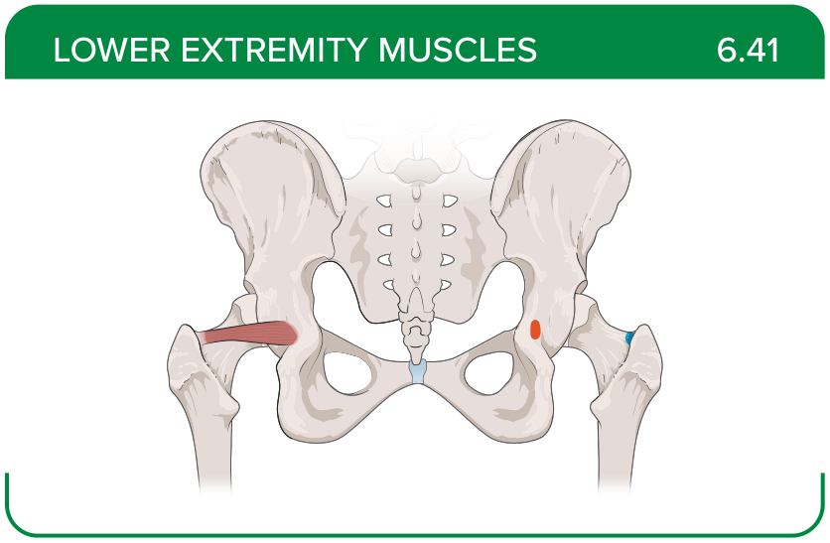
Title: Superior gemellus
Activity Interaction: select all that apply
Back-of-Card Content:
Proximal insertion:
- *ischial spine
- margins of the obturator foramen
- greater sciatic notch
- pubis
Distal insertion:
- *greater trochanter of the femur
- trochanteric fossa of the posterior femur
- linea aspera
Innervation:
- *nerve to the obturator internus
- obturator nerve
- nerve to the quadratus femoris
- tibial nerve
Action:
- *hip external rotation
- *stabilization of the hip joint
- *assistance in abduction of the thigh
- internal rotation
- assistance in adduction of the thigh

Card ID: 6.42
Image file: L1344_760226
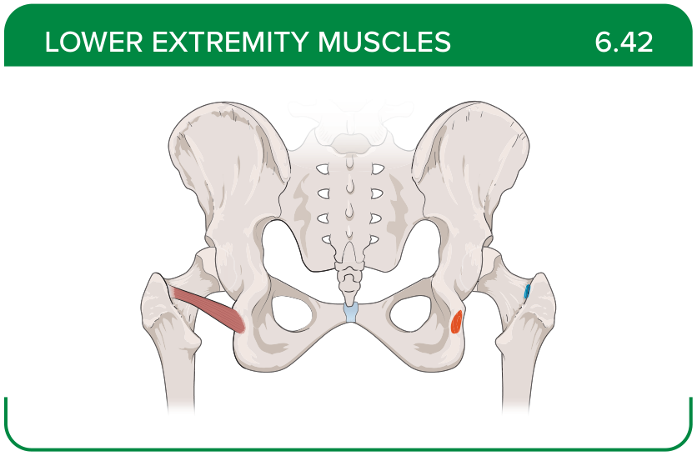
Title: Inferior gemellus
Activity Interaction: select all that apply
Back-of-Card Content:
Proximal insertion:
- *ischial tuberosity
- margins of the obturator foramen
- greater sciatic notch
- pubis
Distal insertion:
- *greater trochanter of the femur
- trochanteric fossa of the posterior femur
- linea aspera
Innervation:
- nerve to the obturator internus
- obturator nerve
- *nerve to the quadratus femoris
- tibial nerve
Action:
- *hip external rotation
- *stabilization of the hip joint
- *assistance in abduction of the thigh
- internal rotation
- assistance in adduction of the thigh

Card ID: 6.43
Image file: L1344_760227
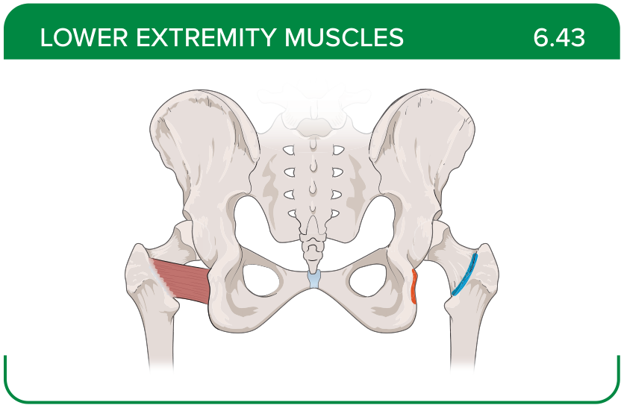
Title: Quadratus femoris
Activity Interaction: select all that apply
Back-of-Card Content:
Proximal insertion:
- *ischial tuberosity
- margins of the obturator foramen
- greater sciatic notch
- pubis
Distal insertion:
- *trochanteric crest of the femur
- greater trochanter of the femur
- trochanteric fossa of the posterior femur
- linea aspera
Innervation:
- nerve to the obturator internus
- obturator nerve
- *nerve to the quadratus femoris
- tibial nerve
Action:
- *hip external rotation
- stabilization of the hip joint
- assistance in abduction of the thigh
- internal rotation
- assistance in adduction of the thigh

Card ID: 6.44
Image file: L1344_760228
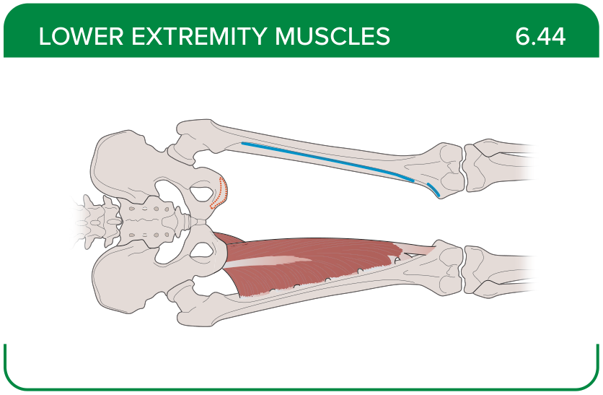
Title: Adductor magnus
Activity Interaction: select all that apply
Back-of-Card Content:
Proximal insertion:
- *ischial rami
- pubic rami
- *ischial tuberosity
- lateral condyle of the femur
Distal insertion:
- *linea aspera
- *adductor tubercle of the femur
- anteromedial fibula shaft
- proximal tibia
Innervation:
- *obturator
- *tibial nerve
- femoral nerve
- deep fibular (peroneal) nerve
Action:
- *hip adduction
- *hip internal rotation
- hip external rotation
- stabilization of the hip joint

Card ID: 6.45
Image file: L1344_760229
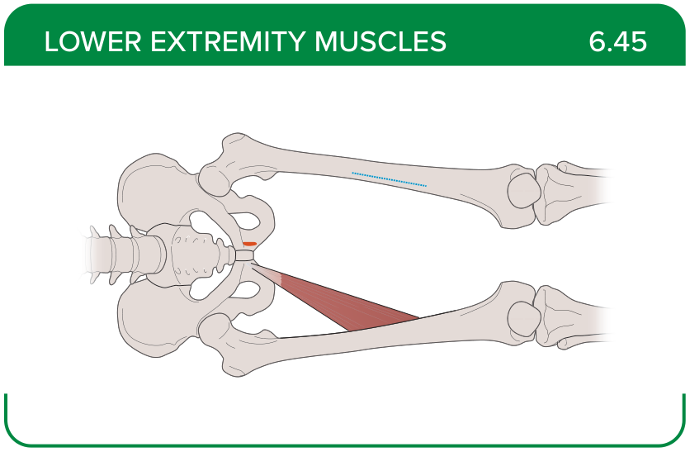
Title: Adductor longus
Activity Interaction: select all that apply
Back-of-Card Content:
Proximal insertion:
- *pubis near the pubic symphysis
- iliopectineal line
- ischial tuberosity
- ischial rami
Distal insertion:
- *linea aspera
- adductor tubercle of the femur
- anteromedial fibula shaft
- proximal tibia
Innervation:
- *obturator nerve
- tibial nerve
- femoral nerve
- deep fibular (peroneal) nerve
Action:
- *hip adduction
- hip internal rotation
- hip external rotation
- stabilization of the hip joint

Card ID: 6.46
Image file: L1344_760230
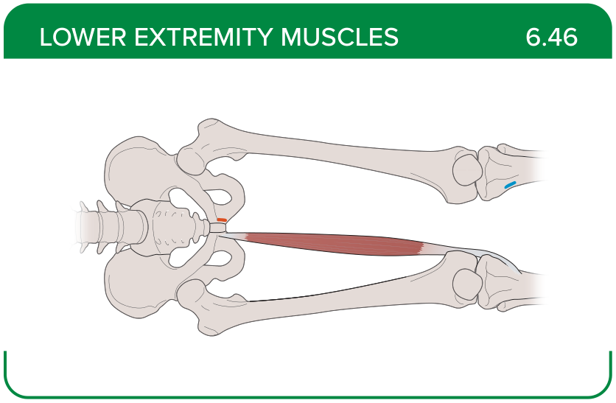
Title: Gracilis
Activity Interaction: select all that apply
Back-of-Card Content:
Proximal insertion:
- *anterior inferior aspect of the pubic symphysis
- *the inferior pubic bone
- ischial tuberosity
- ischial rami
Distal insertion:
- *distal to the medial tibial condyle on the pes anserinus
- anteromedial fibula shaft
- adductor tubercle of the femur
Innervation:
- *obturator nerve
- tibial nerve
- femoral nerve
- deep fibular (peroneal) nerve
Action:
- *hip adduction, flexion, and external rotation
- *knee flexion
- lower leg internal rotation
- *hip adduction, flexion, and internal rotation

Card ID: 6.47
Image file: L1344_760231
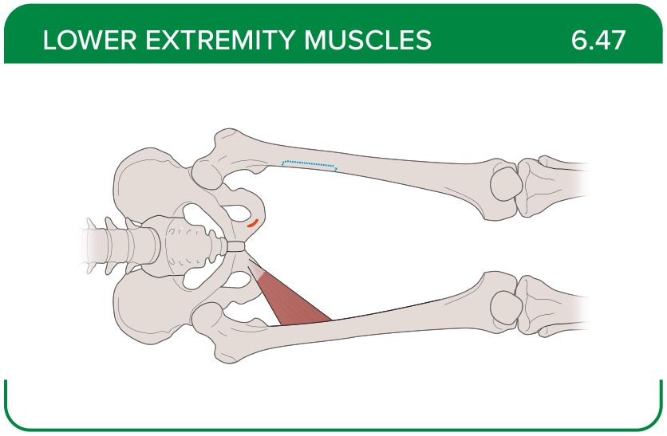
Title: Adductor brevis
Activity Interaction: select all that apply
Back-of-Card Content:
Proximal insertion:
- *body of the pubis
- inferior ramus of the pubis
- ischial tuberosity
- ischial rami
Distal insertion:
- *linea aspera
- distal to the medial tibial condyle on the pes anserinus
- anteromedial fibula shaft
- adductor tubercle of the femur
Innervation:
- *obturator nerve
- tibial nerve
- femoral nerve
- deep fibular (peroneal) nerve
Action:
- hip adduction
- *hip flexion
- *hip internal rotation
- hip external rotation

Card ID: 6.48
Image file: L1344_760232
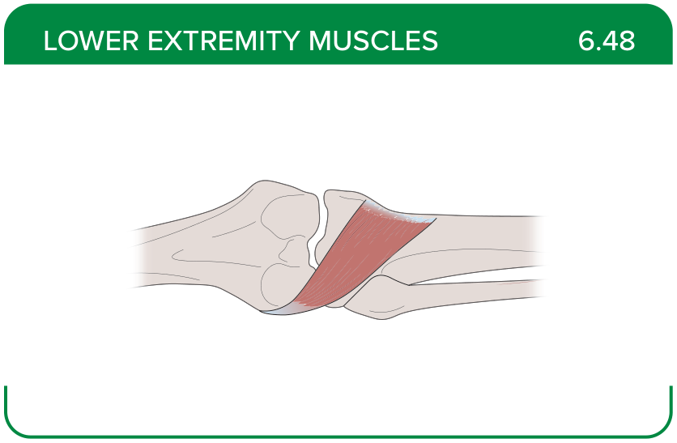
Title: Popliteus
Activity Interaction: select all that apply
Back-of-Card Content:
Proximal insertion:
- *lateral condyle of the femur
- *lateral meniscus
- medial meniscus
- distal to the medial tibial condyle on the pes anserinus
Distal insertion:
- *proximal tibia
- adductor tubercle of the femur
- fibular head
- anteromedial fibula shaft
Innervation:
- superficial fibular nerve
- tibial nerve
- femoral nerve
- *deep fibular (peroneal) nerve
Action:
- *flexes and rotates the leg medially to unlock the extended knee when flexion begins
- flexes and rotates the leg laterally to unlock the extended knee when flexion begins
- extends and rotates the leg medially to unlock the extended knee when flexion begins
- extends and rotates the leg laterally to unlock the extended knee when flexion begins

Card ID: 6.49
Image file: L1344_760233
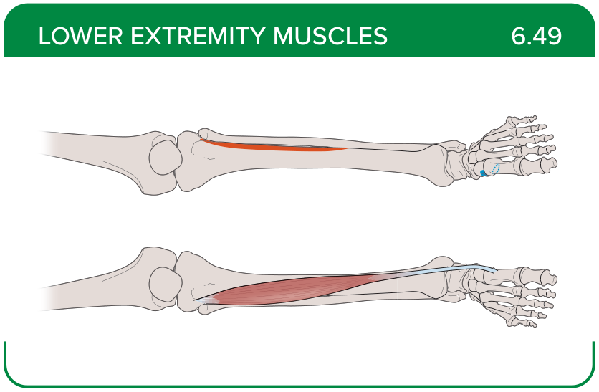
Title: Tibialis anterior
Activity Interaction: select all that apply
Back-of-Card Content:
Proximal insertion:
- *upper two thirds of the lateral surface of the tibia
- fibular head
- distal to the medial tibial condyle on the pes anserinus
- tibial tuberosity
Distal insertion:
- *medial cuneiform
- *first metatarsal
- distal phalanx of the big toe
Innervation:
- superficial fibular nerve
- tibial nerve
- femoral nerve
- *peroneal nerve
Action:
- *foot dorsiflexion
- *foot inversion
- foot eversion

Card ID: 6.50
Image file: L1344_760234
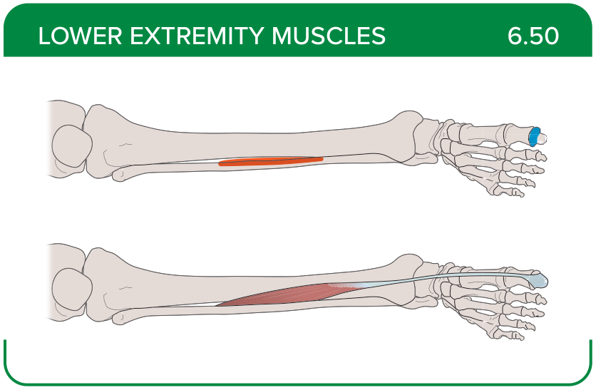
Title: Extensor hallucis longus
Activity Interaction: select all that apply
Back-of-Card Content:
Proximal insertion:
- *anteromedial fibula shaft
- *interosseous membrane
- fibular head
- upper two thirds of the lateral surface of the tibia
Distal insertion:
- *distal phalanx of the big toe
- medial cuneiform
- first metatarsal
Innervation:
- superficial fibular nerve
- tibial nerve
- femoral nerve
- *deep fibular (peroneal) nerve
Action:
- *big toe extension
- *assistance in dorsiflexion of the foot
- assistance in eversion of the foot
- big toe adduction

Card ID: 6.51
Image file: L1344_760235
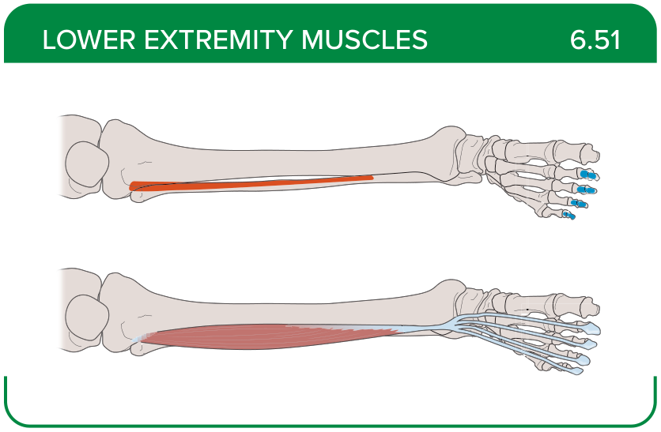
Title: Extensor digitorum longus
Activity Interaction: select all that apply
Back-of-Card Content:
Proximal insertion:
- *lateral condyle of the tibia
- *proximal portion of the fibula
- *interosseous membrane
Distal insertion:
- *middle and distal phalanges of toes two to four
- dorsal aspect of the base of the fifth metatarsal
- medial cuneiform
Innervation:
- *deep fibular (peroneal) nerve
- superficial fibular nerve
- tibial nerve
- medial plantar nerve
Action:
- *toe extension
- dorsiflexion of the foot
- assistance in eversion of the foot
- big toe adduction

Card ID: 6.52
Image file: L1344_760236
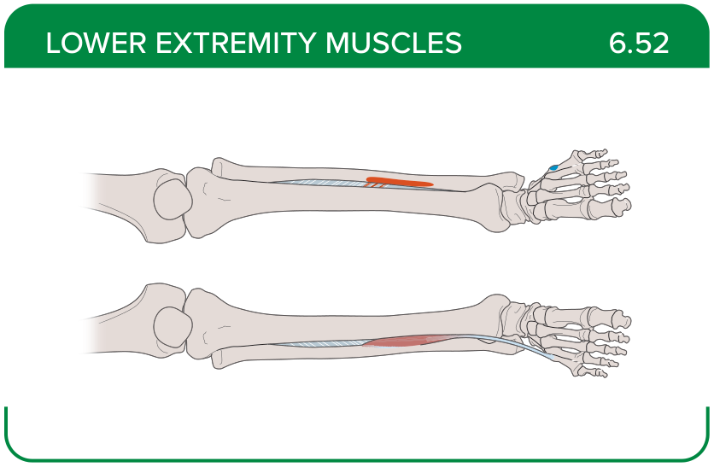
Title: Fibularis tertius
Activity Interaction: select all that apply
Back-of-Card Content:
Proximal insertion:
- distal one third of the fibula
- *interosseous membrane
- fibular head
- lateral femoral condyles

Distal insertion:
- *dorsal aspect of the base of the fifth metatarsal
- lateral cuneiform
- cuboid bones
- dorsal aspect of the base of the second metatarsal
Innervation:
- *deep fibular (peroneal) nerve
- tibial nerve
- tibial nerve from the anterior rami of S1-S2
- superficial fibular nerve
Action:
- *ankle dorsiflexion and eversion
- *ankle eversion
- ankle inversion

Card ID: 6.53
Image file: L1344_760237
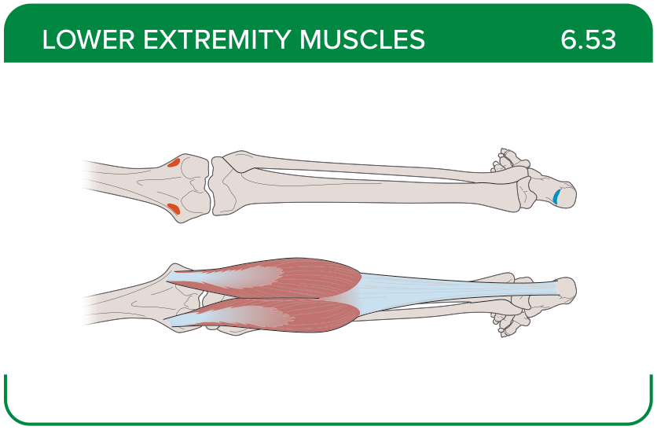
Title: Gastrocnemius
Activity Interaction: select all that apply
Back-of-Card Content:
Proximal insertion:
- *medial femoral condyles
- *lateral femoral condyles
- fibular head
- anteromedial fibula shaft
Distal insertion:
- *posterior calcaneus
- fibularis longus tendon sheath
- base of metatarsals two to four
Innervation: tibial nerve
- deep fibular (peroneal) nerve
- *tibial nerve
- tibial nerve from the anterior rami of S1-S2
- superficial fibular nerve
Action:
- *foot plantar flexion
- *flexion of the knee when the foot is dorsiflexed
- extension of the knee when the foot is dorsiflexed
- foot inversion

Card ID: 6.54
Image file: L1344_760238
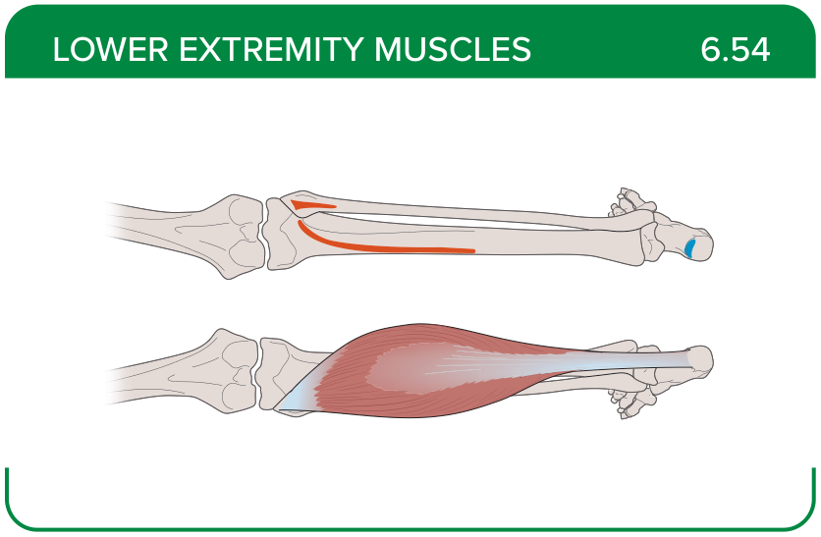
Title: Soleus
Activity Interaction: select all that apply
Back-of-Card Content:
Proximal insertion:
- *superior tibia
- *fibula
- *interosseous membrane
- lateral femoral condyles
Distal insertion:
- *posterior calcaneus
- fibularis longus tendon sheath
- base of metatarsals two to four
Innervation:
- deep fibular (peroneal) nerve
- *tibial nerve from the anterior rami of S1-S2
- superficial fibular nerve
- peroneal nerve
Action:
- *foot plantar flexion
- flexion of the knee when the foot is dorsiflexed
- extension of the knee when the foot is dorsiflexed
- foot inversion

Card ID: 6.55
Image file: L1344_760239
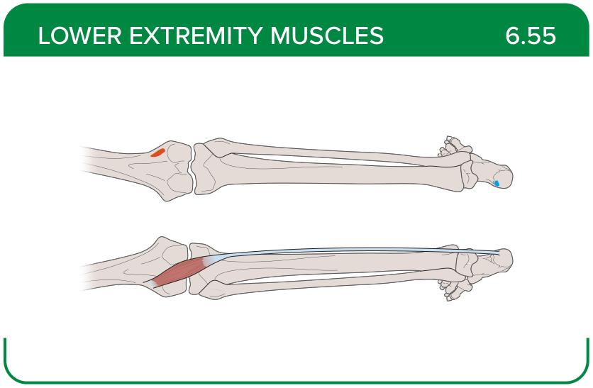
Title: Plantaris
Activity Interaction: select all that apply
Back-of-Card Content:
Proximal insertion:
- *posterior femur above the lateral condyle
- fibula
- interosseous membrane
Distal insertion:
- *calcaneus or calcaneus tendon
- fibularis longus tendon sheath
- medial cuneiform
Innervation:
- fibular nerve
- *tibial nerve from the anterior rami of S1-S2
- superficial fibular nerve
- peroneal nerve

Action:
- *aids in flexing the leg and plantar flexing the foot
- ankle eversion
- flexion of the knee when the foot is dorsiflexed

Card ID: 6.56
Image file: L1344_760240
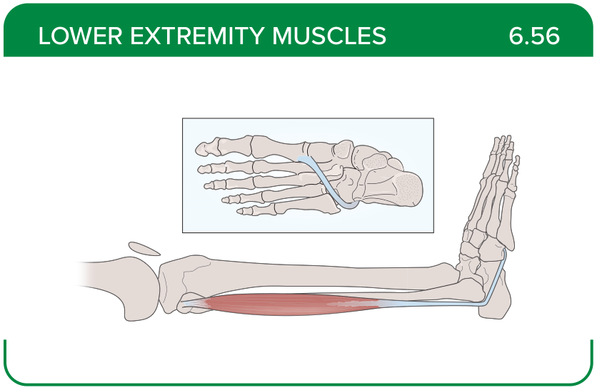
Title: Fibularis longus
Activity Interaction: select all that apply
Back-of-Card Content:
Proximal insertion:
- *upper portion of the lateral fibula
- anteromedial fibula shaft
- interosseous membrane
Distal insertion:
- *first metatarsal
- *medial cuneiform
- lateral cuneiform
- cuboid bones
Innervation:
- deep fibular (peroneal) nerve
- *superficial fibular nerve
- tibial nerve
- medial plantar nerve
Action:
- *foot plantar flexion
- *foot eversion
- foot inversion

Card ID: 6.57
Image file: L1344_760241
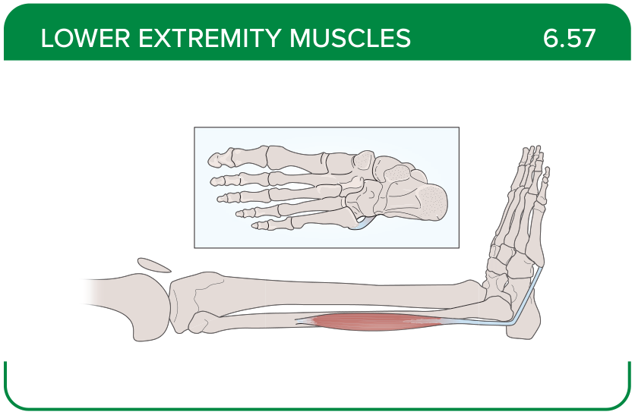
Title: Fibularis brevis
Activity Interaction: select all that apply
Back-of-Card Content:
Proximal insertion:
- *distal fibular shaft
- lateral femoral condyles
- interosseous membrane
Distal insertion:
- *proximal end of the fifth metatarsal
- lateral cuneiform
- cuboid bones
Innervation:
- deep fibular (peroneal) nerve
- *superficial fibular nerve
- tibial nerve
- medial plantar nerve
Action:
- *foot plantar flexion
- *foot eversion
- foot inversion

Card ID: 6.58
Image file: L1344_760242
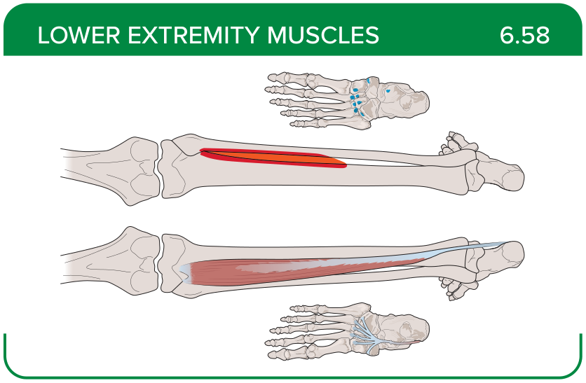
Title: Tibialis posterior
Activity Interaction: select all that apply
Back-of-Card Content:
Proximal insertion:
- *superior tibia and fibula
- interosseous membrane
- medial femoral condyles
- lateral femoral condyles

Distal insertion:
- *tarsals of toes two to four
- metatarsals of toes two to four
- proximal phalanx of toes two to five
Innervation:
- deep fibular (peroneal) nerve
- superficial fibular nerve
- *tibial nerve
- medial plantar nerve
Action:
- *foot plantar flexion
- *foot inversion
- *assistance in stabilizing medial longitudinal arch of the foot

Card ID: 6.59
Image file: L1344_760243
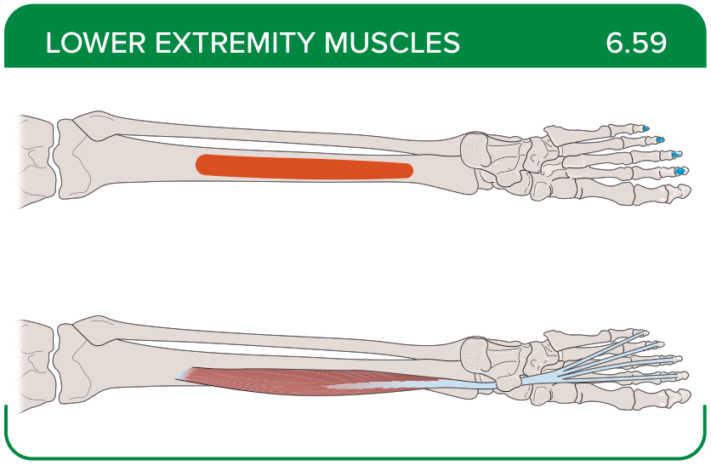
Title: Flexor digitorum longus
Activity Interaction: select all that apply
Back-of-Card Content:
Proximal insertion:
- *posterior tibia
- medial femoral condyles
- lateral femoral condyles
- fibular head
Distal insertion:
- *distal phalanx of toes two to five
- proximal phalanx of toes two to five
- metacarpals of toes two to five
Innervation:
- deep fibular (peroneal) nerve
- superficial fibular nerve
- *tibial nerve
- medial plantar nerve
Action:
- *foot inversion
- *toes two to five flexion
- *foot plantar flexion

Card ID: 6.60
Image file: L1344_760244
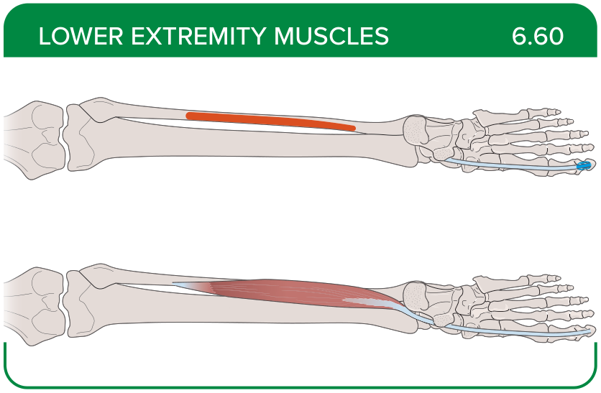
Title: Flexor hallucis longus
Activity Interaction: select all that apply
Back-of-Card Content:
Proximal insertion:
- *midshaft of the fibula
- *interosseous membrane
- lateral femoral condyles
Distal insertion:
- *distal phalanx of the big toe
- dorsal aspect of the base of the second metatarsal
- base of the proximal phalanx of the big toe
Innervation:
- deep fibular (peroneal) nerve
- superficial fibular nerve
- *tibial nerve
- medial plantar nerve
Action:
- *foot plantar flexion
- *foot inversion
- *big toe flexion

Card ID: 6.61
Image file: L1344_760245
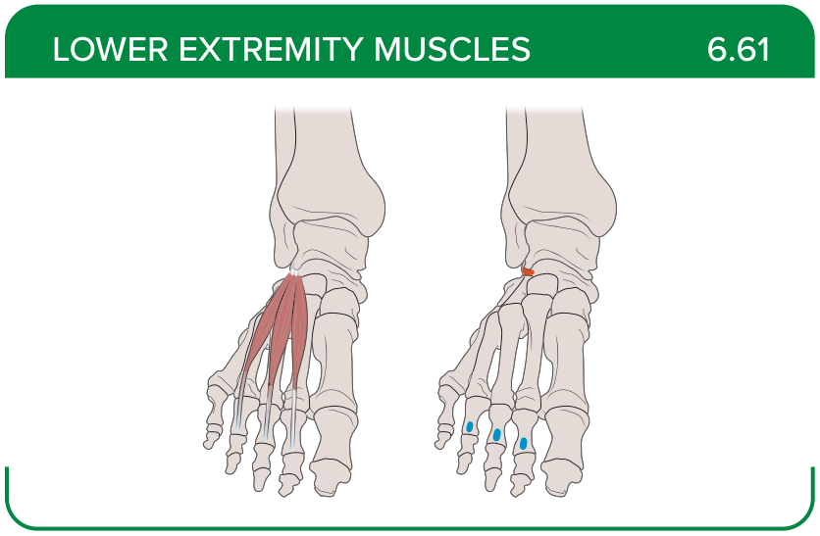
Title: Extensor digitorum brevis
Activity Interaction: select all that apply
Back-of-Card Content:
Proximal insertion:
- *calcaneus
- *extensor retinaculum
- anteromedial fibula shaft
Distal insertion:
- *base of the proximal phalanx of the big toe
- *extensor expansions on toes two to five
- extensor expansion over the first phalanx
Innervation:
- *posterior interosseous nerve
- superficial fibular nerve
- tibial nerve
- medial plantar nerve
Action:
- *toes two to five extension
- big toe extension
- supports the longitudinal arch

Card ID: 6.62
Image file: L1344_760246
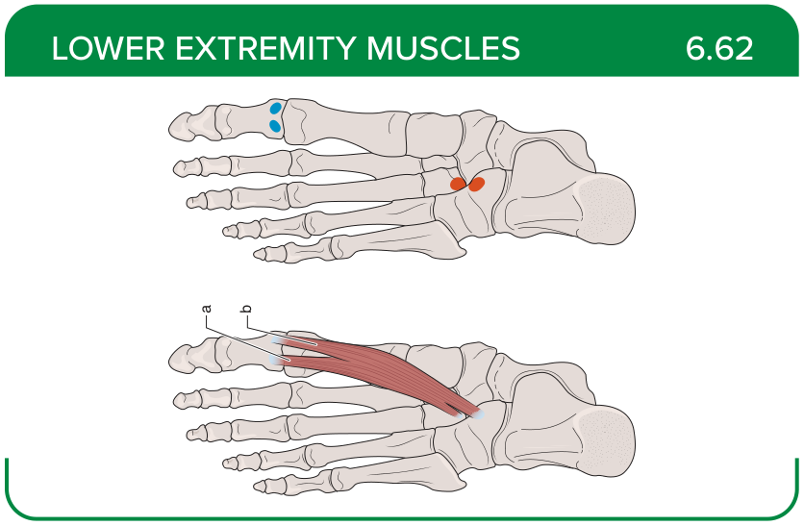
Title: Extensor hallucis brevis
Activity Interaction: select all that apply
Back-of-Card Content:
Proximal insertion:
- *calcaneus
- posterior calcaneus
- lateral cuneiform
- cuboid bones
Distal insertion:
- *distal phalanx of the big toe
- proximal phalanx of the big toe
- lateral aspect of the proximal phalanx of the big toe
Innervation:
- *deep fibular (peroneal) nerve
- superficial fibular nerve
- tibial nerve
- medial plantar nerve
Action:
- *great toe extension
- great toe adduction
- great toe abduction

Card ID: 6.63
Image file: L1344_760247
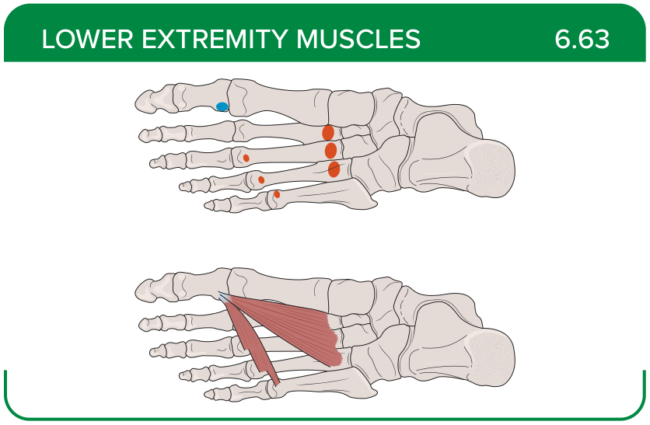
Title: Abductor hallucis
Activity Interaction: select all that apply
Back-of-Card Content:
Proximal insertion:
- *calcaneal tuberosity
- *flexor retinaculum
- ligament across the metatarsophalangeal joints
Distal insertion:
- *proximal phalanx of the big toe
- distal phalanx of the big toe
- dorsal aspect of the base of the second metatarsal
Innervation:
- deep fibular (peroneal) nerve
- superficial fibular nerve
- tibial nerve
- *medial plantar nerve
Action:
- *big toe abduction
- big toe adduction
- big toe extension

Card ID: 6.64
Image file: L1344_760248
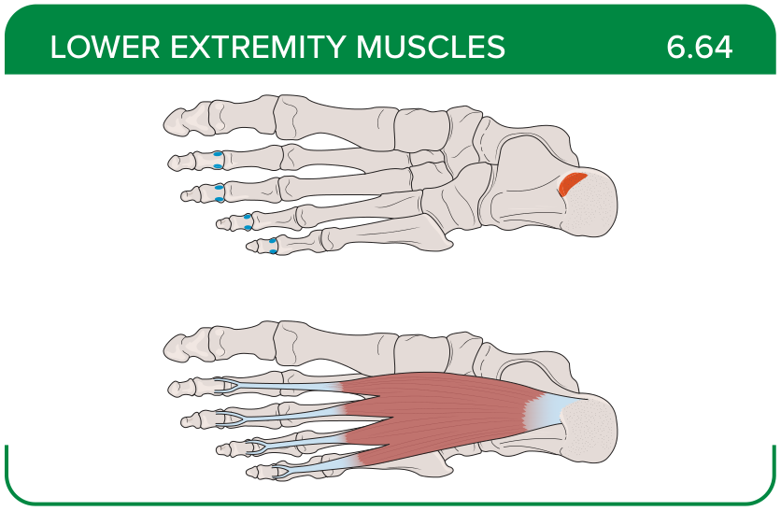
Title: Flexor digitorum brevis
Activity Interaction: select all that apply
Back-of-Card Content:
Proximal insertion:
- *calcaneal tuberosity
- flexor retinaculum
- lateral malleolus
Distal insertion:
- *middle phalanx of toes two to four
- dorsal aspect of the base of the second metatarsal
- extensor expansion over the middle phalanx
Innervation:
- fibular nerve
- tibial nerve from the anterior rami of S1-S2
- superficial fibular nerve
- *superficial branch of the lateral plantar nerve
Action:
- *toes two to five flexion
- provides joint stability
- supports longitudinal arch

Card ID: 6.65
Image file: L1344_760249
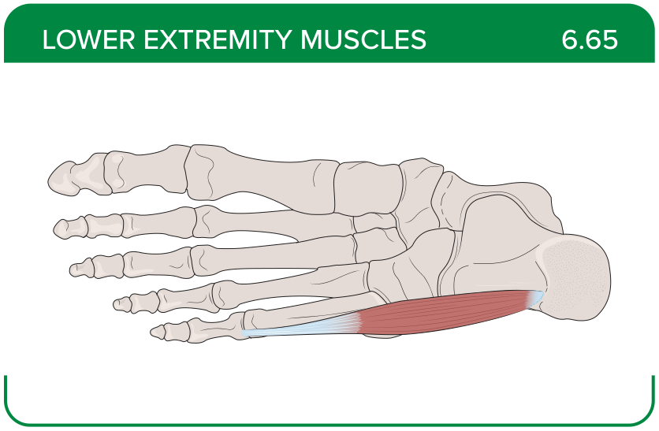
Title: Abductor digiti minimi
Activity Interaction: select all that apply
Back-of-Card Content:
Proximal insertion:
- *calcaneal tuberosity
- *flexor retinaculum
- lateral malleolus
Distal insertion:
- *proximal phalanx of the little toe
- lateral calcaneus
- sustentaculum tali
Innervation:
- deep fibular (peroneal) nerve
- superficial fibular nerve
- * lateral plantar nerve
- medial plantar nerve
Action:
- *fifth toe abduction
- fifth toe flexion
- assists with ankle eversion

Card ID: 6.66
Image file: L1344_760250
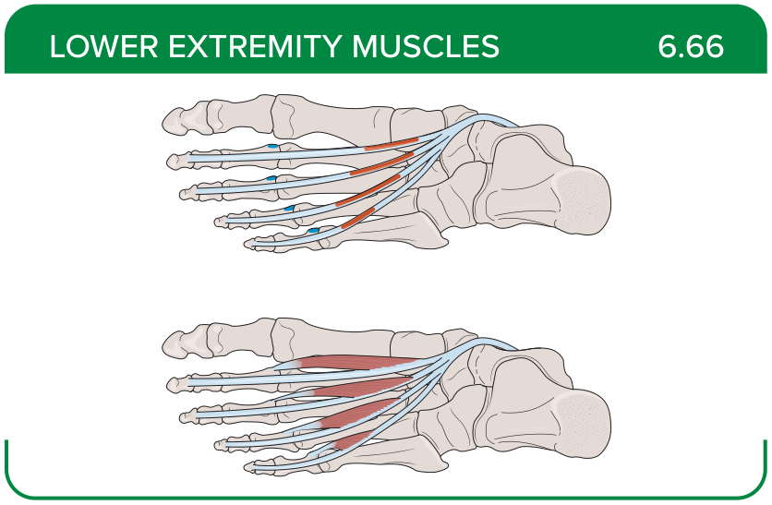
Title: Lumbricals
Activity Interaction: select all that apply
Back-of-Card Content:
Proximal insertion:
- *tendons of the flexor digitorum longus
- distal one third of the fibula
- lateral cuneiform
- interosseous membrane
Distal insertion:
- *medial side of the proximal phalanx of toes two to five
- dorsal aspect of the base of the second metatarsal
- extensor expansion over the first phalanx
Innervation:
- deep fibular (peroneal) nerve
- superficial fibular nerve
- * lateral plantar nerve
- *medial plantar nerve
Action:
- *metatarsophalangeal flexion
- *interphalangeal extension
- interphalangeal abduction
- assists with foot eversion

Card ID: 6.67
Image file: L1344_760251
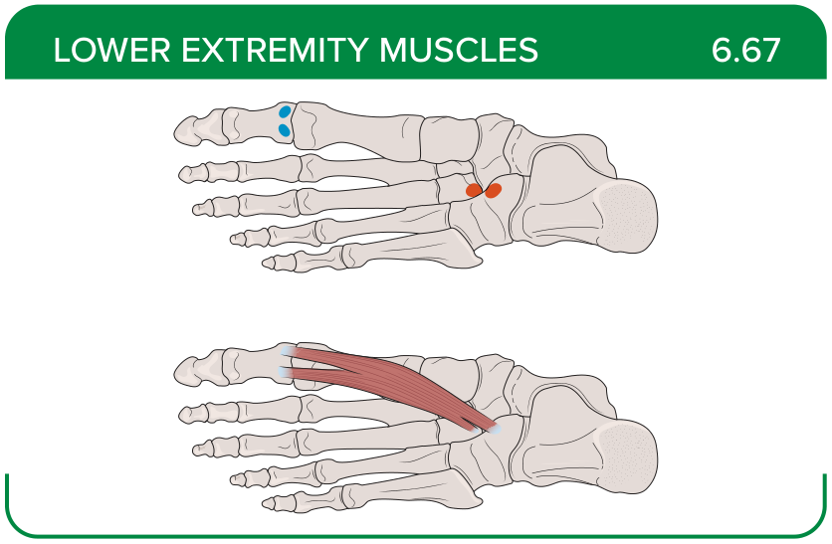
Title: Flexor hallucis brevis
Activity Interaction: select all that apply
Back-of-Card Content:
Proximal insertion:
- *lateral cuneiform
- *cuboid bones
- distal phalanx of the big toe
- dorsal aspect of the big toe
Distal insertion:
- *base of the proximal phalanx of the big toe
- distal phalanx of the big toe
- dorsal aspect of the base of the second metatarsal
Innervation:
- deep fibular (peroneal) nerve
- superficial fibular nerve
- lateral plantar nerve
- *medial plantar nerve
Action:
- *big toe flexion
- big toe abduction
- big toe adduction
- big toe extension

Card ID: 6.68
Image file: L1344_760252
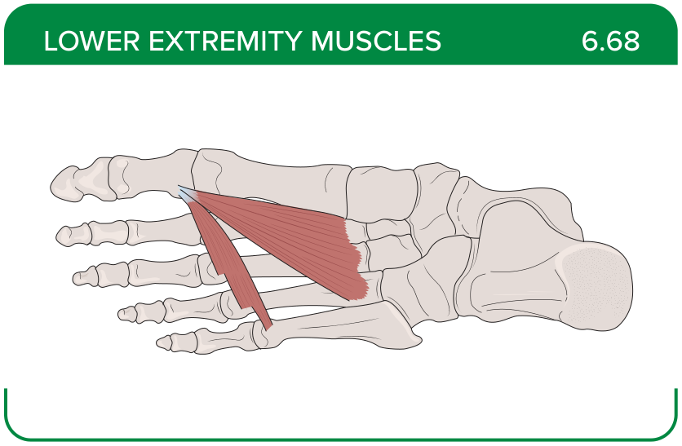
Title: Adductor hallucis
Activity Interaction: select all that apply
Back-of-Card Content:
Proximal insertion:
- *base of metatarsals two to four
- *fibularis longus tendon sheath
- *ligament across the metatarsophalangeal joints
Distal insertion:
- *base of the proximal phalanx of the big toe
- distal phalanx of the big toe
- dorsal aspect of the base of the second metatarsal
Innervation:
- deep fibular (peroneal) nerve
- superficial fibular nerve
- * lateral plantar nerve
- medial plantar nerve
Action:
- big toe flexion
- big toe abduction
- *big toe adduction
- big toe extension

Card ID: 6.69
Image file: L1344_760253
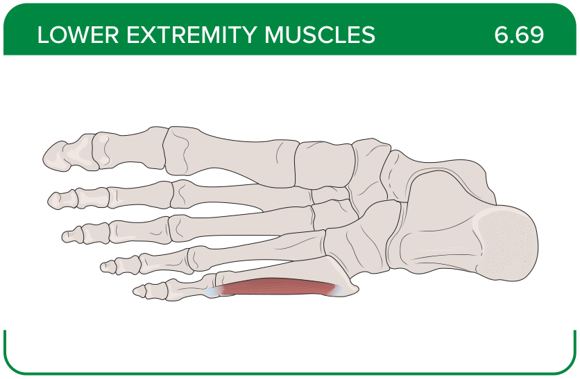
Title: Flexor digiti minimi brevis
Activity Interaction: select all that apply
Back-of-Card Content:
Proximal insertion:
- *base of the fifth metatarsal
- *tendon sheath of the fibularis longus
- posterior calcaneus
Distal insertion:
- *base of the proximal phalanx of the little toe
- extensor expansion over the first phalanx
- sides of the metatarsals
Innervation:
- deep fibular (peroneal) nerve
- superficial fibular nerve
- * lateral plantar nerve
- medial plantar nerve
Action:
- *small toe flexion
- small toe abduction
- small toe adduction

Card ID: 6.70
Image file: L1344_760254
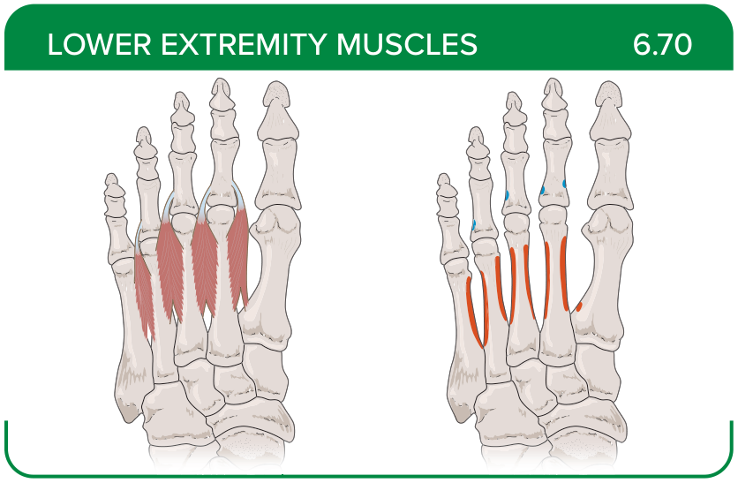
Title: Dorsal interossei
Activity Interaction: select all that apply
Back-of-Card Content:
Proximal insertion:
- *sides of the metatarsals
- base of the fifth metatarsal
- tendon sheath of the fibularis longus
Distal insertion:
- *both sides of toe two
- *extensor expansion over the first phalanx
- on the side opposite toe two
- base of the proximal phalanx of the little toe
Innervation:
- deep fibular (peroneal) nerve
- superficial fibular nerve
- * lateral plantar nerve
- medial plantar nerve
Action:
- *middle toes at the metatarsophalangeal joints’ abduction and flexion
- *middle toes at the interphalangeal joints’ extension
- big toe metatarsophalangeal joint’s abduction and flexion
- middle toes at the metatarsophalangeal joints’ adduction

Card ID: 6.71
Image file: L1344_760255
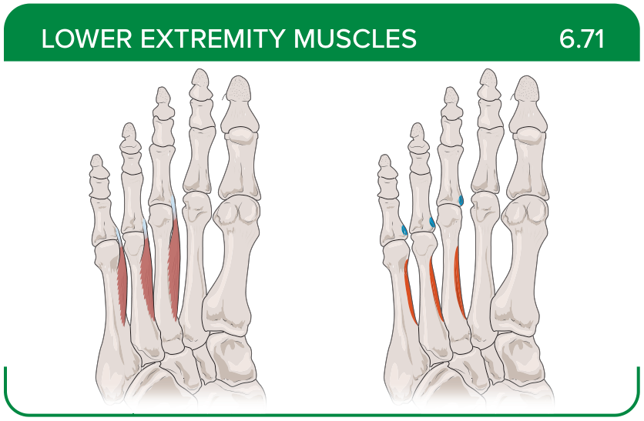
Title: Plantar interossei
Activity Interaction: select all that apply
Back-of-Card Content:
Proximal insertion:
- *side of each metatarsal that faces metatarsal two
- distal phalanx of each toe
- plantar surface of each metatarsal
Distal insertion:
- *extensor expansion of the first phalanx of each toe facing toe two
- distal phalanx of each toe
- plantar surface of each metatarsal
Innervation:
- deep fibular (peroneal) nerve
- superficial fibular nerve
- * lateral plantar nerve
- medial plantar nerve
Action:
- *toes three to five abduction
- *proximal phalanges flexion
- *distal phalanges extension
- proximal phalanges extension
- distal phalanges flexion

